TRINITY PRIMARY SCHOOL- BUKOTO
REVISION WORK
CLASS: P.3
SUBJECT: LITERACY
Name: ………………………………....…..Stream: ……………….
- Name any one important place at school.
________________________________________________________________
- State one member of an extended family.
________________________________________________________________
- Which domestic animal provides us with milk?
________________________________________________________________
- Who keeps law and order in a community?
________________________________________________________________
- Identify one importance of a school prayer.
________________________________________________________________
- Give one way of caring for your young brothers and sisters.
________________________________________________________________
- Name this school symbol.
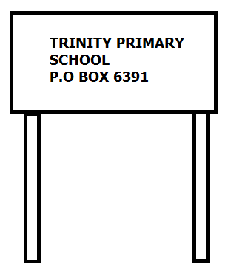_______________________________
- Mention one way we can keep our body clean.
_____________________________________________________________

- What is a school?
_____________________________________________________________
- Give any three examples of bad behaiviour at school.
(i)___________________________________________________________
(Ii)__________________________________________________________
(iii)__________________________________________________________
- What is germination?
_____________________________________________________________
- Mention any two conditions necessary for germination.
(i)___________________________________________________________
(ii)___________________________________________________________
- State any two ways of caring for crops in a garden.
(i)___________________________________________________________
(ii)___________________________________________________________
- Name the type of soil best for crop growing.
_____________________________________________________________
- Identify these items used for cleaning our body.
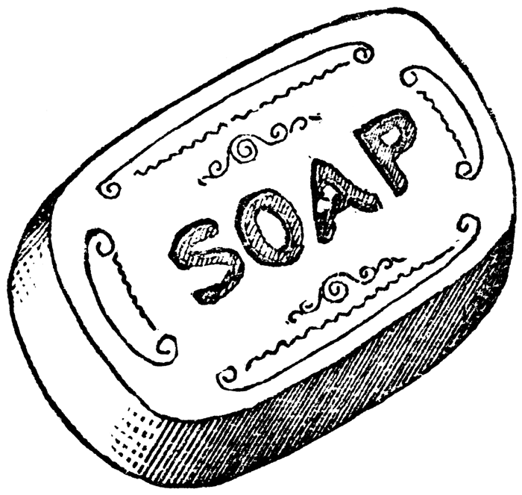 | 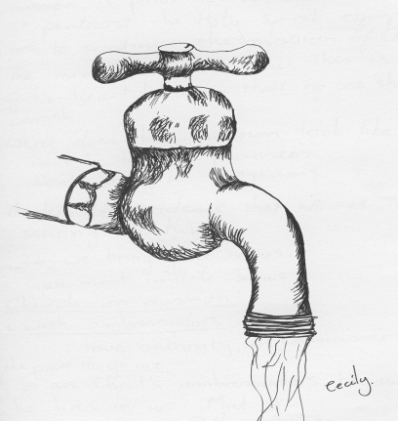 | 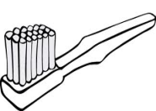

- Mention the infant killer disease that makes children lame.
_____________________________________________________________
- Give one way of keeping your classroom clean.
_____________________________________________________________
- Which example of food do you mostly eat at school?
_____________________________________________________________
- State one way of caring for our animals.
_____________________________________________________________
- What is a home?
_____________________________________________________________
- Name any two natural sources of water.
(i)______________________________ (ii)_________________________________
- Draw one example of food you eat at home.

- Why do children go to school?
_____________________________________________________________
- Draw a map of a tree.

- Mention any two attributes of a school.
(i)_________________________________________________________
(ii)_________________________________________________________
- Name the map symbol shown below.
______________________________________________________________________
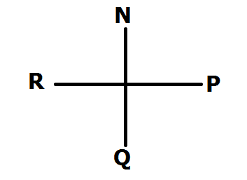
- Identify the points marked P, Q and R.
- P__________________________________________________
- Q_________________________________________________
- R_________________________________________________
- Write down two groups of people who use the instruments above.
(i)___________________________(ii)_________________________
- How do the following animals move?
- Frog ___________________________________________________
- Snake _________________________________________________
- Fish ____________________________________________________
- In which way are some insects useful to people.
_____________________________________________________________
……………….End……………...

