**TRINITY PRIMARY SCHOOL-BUKOTO**

|  |  |
| --- | --- |
| **SECTION** | **MARKS** |
| **A** |  |
| **B** |  |
| **TOTAL** |  |

**REVISION WORK**

**CLASS : P.2**

**SUBJECT : LITERACY**

**Name: _______________________________________**

**Stream: ______________________________________**

1. **Who heads a school?**

**_____________________________________________________________**

1. **Name any one thing used to keep peace and security.**

**______________________________________________________________**

1. **Why do children go to school?**

**______________________________________________________________**

1. 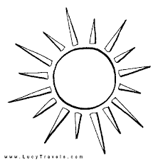**Name the source of light below.**

**________________________**

1. **What do we call a person who builds houses?**

**_____________________________________________________________**

1. **Write any one important place in our community.**

**______________________________________________________________**

1. 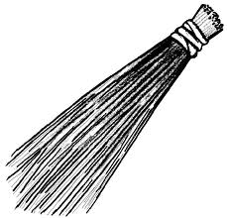**7. How is this item useful in a home?**

**__________________________________________**

1. **Mention the body part used for smelling.**

**______________________________________________________________**

1. **Mention the means of transport below.**

|  |  |  |
| --- | --- | --- |
|  | 1. images | Description: https://encrypted-tbn0.gstatic.com/images?q=tbn:ANd9GcRiEk33smedGwv44Am7U5n3Y-D1g49p9_61lCDefZhHrNigL2rn8A |
|  |  |  |

1. **How do people manage rainy weather?**

**_____________________________________________________________**

1. **Mention one activity done after visiting the toilet.**

**_____________________________________________________________**

1. **Draw one thing used for cleaning teeth.**

|  |
| --- |
|  |
| **tooth brush** |

1. **How does a fish move?**

**______________________________________________**

1. **Write down one Item that can be made out of banana fibre.**

**________________________________________________**

1. **Name this type of family.**

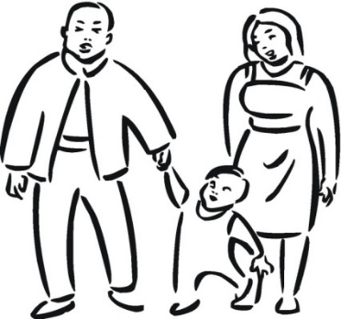

**____________________________________________**

1. **Which group of animals are kept at home?**

**____________________________________________________________**

1. **Underline one common disease below;**

**polio tuberculosis malaria tetanus**

**SECTION B**

1. **Match correctly.**

**doctor teaches pupils**

**carpenter catches fish**

**fishermen makes furniture**

**teacher treats patients**

1. **How are these body parts useful to people?**

**__________________________________________________**

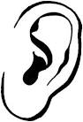**______________________________________________**

1. **Write one way of keeping the body clean.**

**____________________________________________________________**

1. **What are the young ones of the following animals?**
2. **hen ___________________________________________________**
3. **cat __________________________________________________**
4. **How does the animal below move?**

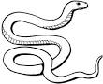

**_______________________________________________**

1. **Name this animal’s home.**

|  |
| --- |
| **https://encrypted-tbn1.gstatic.com/images?q=tbn:ANd9GcTWaW9UIqk5DX7Zwy70El2onBY342OJeO-7DnoMcByAeo0gLwWbSA** |
|  |

1. **Draw and name any two things made out of animal skins.**

|  |  |
| --- | --- |
|  |  |
|  |  |

**…………end………..**