TRINITY PRIMARY SCHOOL-BUKOTO
REVISION WORK
CLASS: P.1
SUBJECT: METHEMATICS
Name: ……………………………………………………Stream: ……………..
- Draw the sets.
A set of three balls

A set of five pencils

- Fill in the missing numbers.
10, _____ , 8 , _____ , 6 , _____ , 4 _____ , 2 , _____
- Count and write the numbers in words.
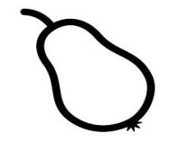=__________________

=_____________

= __________________
- Show the time.
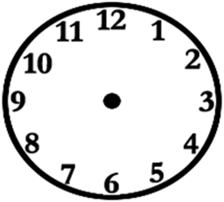
It is 4 o’clock It is 8 o’clock

- Compare the sets.
A B
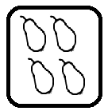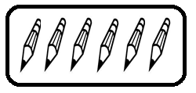
- How many members has set B?

- Which set has less members?

- Which set has more members?

- Count the tens and ones.
_______ tens _______ ones
3 tens 6 ones = ____________
48 = ______ tens ______ ones

- Add
5 4 chairs
+ 3 2 chairs
+3 chairs

- What is 7 plus 5?

- Ali has 6 pencils and Moses has 7 pencils.
- Who has more pencils?

- Who has fewer pencils?

- How many pencils do they have altogether?

- Take away.
9 8 cups
- 6 - 3 cups

- Sarah had 7 cakes. She ate 4 cakes. How many cakes were left?

- 2 groups of 5= _________________

- Draw the numbers on the abacus.
24 = T O 30 = T O

- Join the sets.
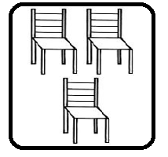 + 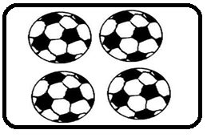 =

- Write the numbers in figures.
thirteen __________ twenty four ______________

- Study the pictures and answer the questions.

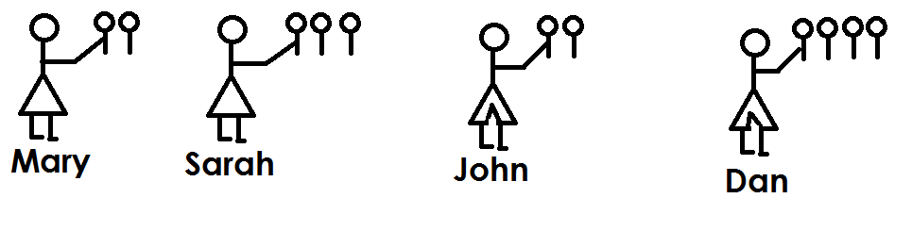
- How many sweets has Sarah?

- Who has more sweets?

- Who has fewer sweets?

- How many sweets do they have altogether?

END

