TRINITY PRIMARY SCHOOL-BUKOTO
NATURE OF WORK: REVISION WORK
SET: 5
SUBJECT: SCIENCE
CLASS: P.5
NAME: ______________________________ DATE ___________
SECTION A
- Name the structures used by fish for exchange of gases.
__________________________________________________________________________
- How is a cat useful at home?
________________________________________________________________________
- Identify the use of the garden tool shown below.
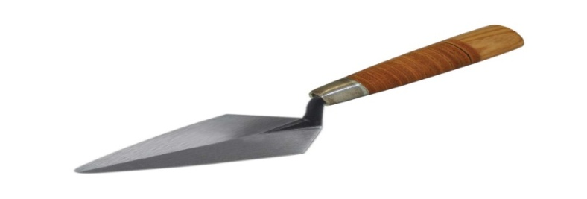
___________________________________________________________________________
- Write down one example of an object that floats on water.

- Give one example of a plant with tap root system.
________________________________________________________________________
- Mention one reason why we eat food.
_________________________________________________________________________
- Name the instrument used to measure temperature.
________________________________________________________________________
- Why are crop pests said to be dangerous to farmers?
________________________________________________________________________
- Why is it dangerous to eat cold left over food?
_______________________________________________________________________
- Which part of a seed stores food for the embryo?
_______________________________________________________________________

- A part from protection against enemies. State another reason why animals move from place to place. _________________________________________________________________________
- Why is it good to keep our latrines and toilets clean?
_____________________________________________________________________

- Which part of a plant grows into branch?
______________________________________________________________________
- State any one way of preventing germs.
_____________________________________________________________________
- Why is it bad to eat undercooked meat?
_____________________________________________________________________
- Name the clouds in the sky which are sign of storm.
______________________________________________________________________
- Define the term mulching in soil conservation.
______________________________________________________________________
- In which way can we prevent road traffic accidents?
______________________________________________________________________
- Identify one reason why we should keep our bodies clean.
_____________________________________________________________________
- Which stage of a butterfly is dangerous to farmers?
_____________________________________________________________________
- Give the main reason why a fern is classified as non-flowering plant
_____________________________________________________________________
- Why is breast milk the best food for babies below two years?
______________________________________________________________________
- How useful is mulching gardens to farmers?
______________________________________________________________________
- Give one danger of too much rainfall
_____________________________________________________________________

- Why should one brush teeth?
_____________________________________________________________________
- Name the type of weather which needs woolen clothing.
_____________________________________________________________________
- How can food be prevented from contaminated?
_____________________________________________________________________

- How are brightly colouredflowers pollinated?
_____________________________________________________________________
- In which way is the human skull important?
______________________________________________________________________
- Name the gas needed for the process of photosynthesis.
_____________________________________________________________________
- Give the reason why sleeping under treated mosquito net is good health practice.
____________________________________________________________________
- Write one method of maintaining sanitation.
_____________________________________________________________________
- Name the main activity which promotes healthy teeth.
______________________________________________________________________
- Identify the garden tool used for watering crops in dry weather.
_____________________________________________________________________
- Which compound leaf is shown below?

____________________________________________________________________
- Give the part of alimentary canal that absorbs digested food.
____________________________________________________________________

- Which parts of an insect help it to exchange gases?
_____________________________________________________________________
- Why should we always dispose of faeces properly?
_____________________________________________________________________
- Identify one characteristic of living things.
_____________________________________________________________________
- Define the term Digestion.
_____________________________________________________________________
SECTION B
- (a) Why are insects like cockroaches said to be vectors?
_____________________________________________________________________
(b) Give two other examples of insect vectors.
(i) _________________________________________________________________
(ii)________________________________________________________________
(c) How can we prevent cockroaches in homes?
_______________________________________________________________________
- (a) Explain the term weeding in crop growing
______________________________________________________________________
(b) Give any two examples of weeds
(i)_________________________________________________________________
(ii) _______________________________________________________________
(c) Write down one use of weeding.
_________________________________________________________________________
- (a)Why do we wash hands with clean water and soap?
________________________________________________________________________
(b) Mention two groups of germs besides viruses.
(i)________________________________________________________________
(ii) ________________________________________________________________
(c) Give one way through which spread of germs can be prevented.
_________________________________________________________________________

44. (a) Name the part of flower that protects it when still in bud stage.
___________________________________________________________________________
(b) What does each part below develop into after fertilization?
(i) Ovule__________________________________________________________
(ii) Ovary_________________________________________________________
(c) Identify any one type of pollination.
__________________________________________________________________________
45. (a) what is first aid?
_________________________________________________________________________

(b) Out line two reasons why we give first.
(i) _______________________________________________________________
(ii)________________________________________________________________
(c) Explain the first stage given to a casualty with snake bite.
_________________________________________________________________________
46. Use the diagram below to answer questions that follow
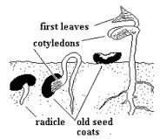
- Which type of germination is shown above?
_______________________________________________________________________
- Give two examples of plants with such type of germination.
- ________________________________(ii) ______________________________
- Why do you think the cotyledons are unnecessary after fully growth of foliage leaves?
_____________________________________________________________________
47. (a) Give one reason why some farmers keep rabbits.
________________________________________________________________________

(b) Write down two examples feeds given to rabbits.
(i) _________________________________ (ii) ___________________________________
- Mention one disease which attacks both rabbits and poultry.
______________________________________________________________________
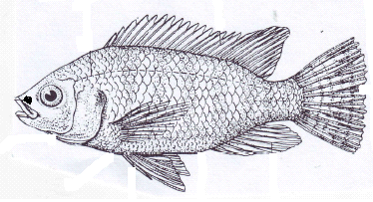48. Below is a diagram of fish. Use it to answer questions that follow

- Name the parts marked W and X.
- W________________________(ii) X_________________________
- Write down the use of part marked S.
________________________________________________________________________
- Where does the above animal live?
______________________________________________________________________
49. (a) Define the term crop pest.
______________________________________________________________________
(b) Mention two examples of pests.
(i) ____________________________(ii) ____________________________________
(c) Give one method of controlling pests in garden without using chemicals.
________________________________________________________________________
50. (a) Which part of air is used for respiration or burning food?
________________________________________________________________________
(b) Which gas occupies the highest percentage in atmosphere?
_______________________________________________________________________
(c) Identify any two properties of air.
(i) ____________________________________________________________
(ii) ____________________________________________________________

51. The diagram below shows the structure of a tooth. Use it to answer questions that follow.

- Name the parts marked with S and P.
(i) S____________________________ (ii) P __________________________
(b) Mention one method of caring for teeth.
_______________________________________________________________________

- Give two diseases which can attack the above shown organ
- _______________________________(ii)________________________________
52. (a) Mention one use of roots to a plant.
_______________________________________________________________
- In which two ways do people use plant roots
- __________________________________________________________________
- ___________________________________________________________________
- What name is given to swollen roots with stored food?
_________________________________________________________________________
53. (a) Identify any two materials which we can use to clean our bodies
(i) _________________________________________________________________________
(ii) _________________________________________________________________________
- Give one reason why we should iron school uniform.
___________________________________________________________________________
- Identify one disease which can result from poor personal hygiene.
__________________________________________________________________

54. P.5 pupils carried out an experiment in which transparent polythene paper was tied around leaves. After few hours, water droplets formed on the inside polythene.
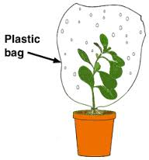
- What did such an observation show?
______________________________________________________________________
- Write down one factor that determines the rate of the process mentioned in ‘a’ above.
______________________________________________________________________
- Apart from the above process, give other two uses of leaves to plants
_______________________________________________________________________________________________________________________________________________

55. In four sentences, outline the steps you can follow when preparing SSS at home.
________________________________________________________________________________________________________________________________________________________________________________________________________________________________________________________________________________________________________________________________________________________________________________

