TRINITY PRIMARY SCHOOL-BUKOTO
NATURE OF WORK: REVISION WORK
SET: 5
SUBJECT: MATHEMATICS
CLASS: P.4
NAME: ______________________________ DATE ___________
SECTION A:
1. | Add: 12+ 12 = | 7. | Change 4 weeks to days.
2. | Find the value of 5 tens. | 8. | Write 781 in words.
3. | Name the set symbol below. | 9. | Work out: +3 = 9
4. | What is the sum of 21 and 20? | 10. | Arrange the following numbers from smallest to biggest.  10, 5, 7, 12, 3, 2
5. | Draw a cone in the space provided below. | 11. | represents 12 balls.How many balls are represented by?
6. | Subtract: ⁵/₁₀ – ²/₁₀ = | 12. | Find the place value of 2 in the number  4264.

13. | Show 7o’clock on the clock face below.  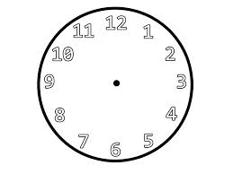 |  | 17. |  | Describe the shaded region.  Y  X
14. | Use a number line to work out 10 -7. |  | 18. |  | One book costs 500/=.what is the cost of 4 similar books?
15. | Complete using a correct operation  +, _, ÷, or x.  12 6 = 2 |  | 19. |  | Find the perimeter of the figure below.  3 cm  6cm
16. | Using repeated addition, complete  4 + 4+ 4 = 4 x_____ |  | 20. |  | Musa had sh.1000 and bought  a book at sh.600.How much did he remain with?
21. | SECTION B:  (a) Tell the time shown on the clock face.  (i) _______________  (ii) ________________  (b) Show 20 minutes past 3 o’clock. |  | 23. |  | Below is Loreta’s shopping list. Use it to answer questions that follow.  -Sugar for sh.3,000 each kg  -Bread for sh.4,000 each loaf  -Rice for sh.2,000 each kg.  - How much did she use to buy 2 kgs of sugar?  (b) Name the cheapest item.  (c) Find the total cost of the three items.
22. | (a) Work out the area of the rectangle below.  2cm  6 cm  (b) Find the perimeter of the rectangle above.
 |  |  | 24. |  | (a) Draw a cuboid in the space below.
24. | - Name the shapes below.  __________________________  (ii)  _______________  (iii)  _________________  (iv) _______________________ |  | - Find the number of elements found in set K.  - How many elements are there in set KUM?  - List down all members which form set K∩M.
26.
Tom Alex Ali
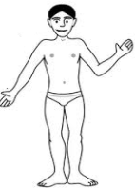__10m_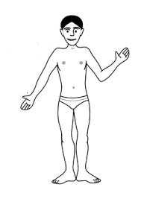____5 m__
(a) Which two boys are 5m apart?
25. | Study the Venn diagram below and use it to answer questions that follow.  K M  a f g b h  a  e d c  a
 | (b) What is the distance between Tom and Ali?  - Find the distance between Tom and Alex. |  |  | (b) On which day did the above Month start?  (c) How many Sundays are in the above Month?  - How many days are in the above Month?
27. | Use the calendar below to answer questions that follows.  S M T W T F S  1  2 3 4 5 6 7 8  9 10 11 12 13 14 15  16 17 18 19 20 21 22  23 24 25 26 27 28 29  30  - How many full weeks are in the month above?
28. Study the magic square below
9 | a | 7
c | 6 | 8
5 | b | 3
(a)Find the magic sum.
 | - Find a.  - Find b.  - Find c. |  |  | (b) How old is Alfred than Martin?  (c) Who is younger?  (d) What is their total age?
29. | Work out:  - + 5 = 15  - - 3 = 10
 |  | 31. |  | Mukisa ate ¹/₅ of a mango and Mwebaza ate ²/₅ of a mango.  - Who ate the biggest part?  - What fraction did they eat altogether?
30. | Alfred is 26 years old. Martin is 19 years old.  - How old is Alfred?

- Shade the fraction Mukisa ate.

= ¹/₅

32. | Complete the table below correctly by showing the working.  WEEKS 1 _____ 2 _____ 5  DAYS 7 28 ______ 21 ______

