TRINITY PRIMARY SCHOOL- BUKOTO
REVISION WORK
CLASS: P.2
SUBJECT: MATHEMATICS
Name: …………………………………………....…………stream: …………………
- Count and write.
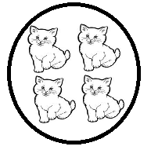
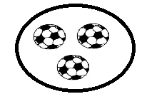
- What number comes before?
6 ____________________
9 ____________________
20 ____________________
- Work out the following numbers.
3 1 4 3 3 3
+4 2 +2 1 +1 2

3 + 4 + 5 = 2 + 9 + 10 =
- Peter has five bags. Willy has seven bags. How many bags do they have altogether?

- Let’s subtract.
8 9 10 – 3= 9 6
-2 3 -1 5

- Mummy had twenty tomatoes. Sixteen of them got rotten. How many tomatoes did mummy remain with?

- Name these shapes.

- Study the graph and answer the questions that follow in full sentences.
Liam 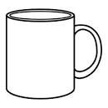
Abbey
Melanie
Mark

Questions.
- Who got six cups?
_______________________________________________________
- How many cups did Mark get?
______________________________________________________
- Write the names of people on the graph which start with letter M.

____________________________ __________________________
- How many cups did Abbey and Liam get?

- What is the total numbers of cups shown?

- Who got the least number of cups?

- Who got many cups?

- Study the graph and answer the questions in full sentences.
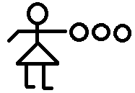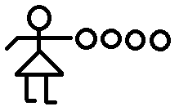
Joy Sarah Jane
- Which people have the same number of oranges?
___________________________________________________
- How many oranges do they have altogether?
___________________________________________________
- Who has four oranges?
____________________________________________________

- Complete the table below.
20 |  |  | 23
30 |  |  |  | 34
40 |  |  |  |  | 45
50 | 51
60 |  | 62

- Draw these sets.
An empty set

A set of nine stars

- Form and name the new sets.
