**TRINITY PRIMARY AND PRESCHOOL - BUKOTO**

**REVISION WORK FOR P.1 RE, 2020**

**Name…………………………………… Stream: …………**

1. Name the body part God gave us for seeing**. _________________________________________________**
2. On which day do Christian go to church**? (Friday, Sunday) ___________________________________________**
3. How is a dog useful in our home**?** **_______________________________________________**
4. Who heads a family**?** **________________________________________________**
5. Name this thing God created to give us water.



__________________________________

1. Which name means a rock**?** **_________________________________________________**
2. Give one use of the sun at home. **_________________________________________________**
3. Who created the world**?** **_________________________________________________**
4. Name these places of worship.

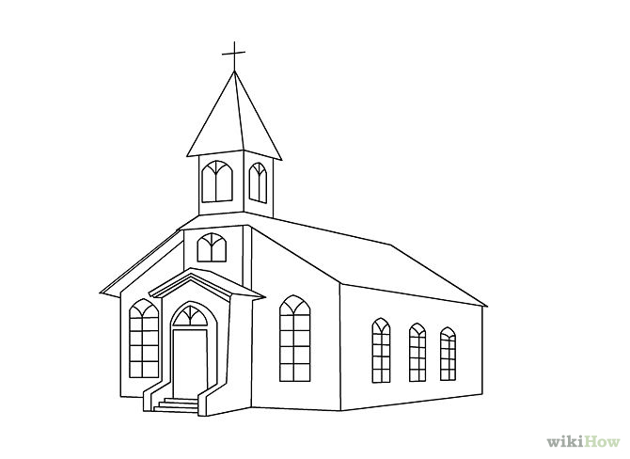

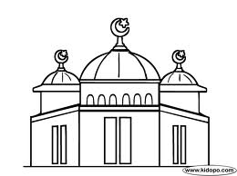

______________________________________ ___________________________

1. Give one role of a mother at home. **_________________________________________________**
2. What is the work of a school nurse**?** **________________________________________________**
3. 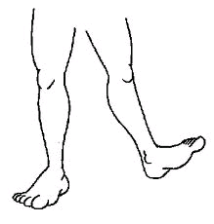

What is the use of this body part god gave us as a gift**?** **____________________________________**

1. How do we call the animals we keep at home? **____________________________** (wild animals, domestic animals)
2. Give the holy book for Christians. **_____________________________________________**
3. Write your religious name. **________________________________________________**
4. Write Religious Education in short. **______________________________________________**
5. Mention this needy person.

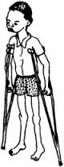

**___________________________**

1. Who died for our sins**?** **________________________________________________**
2. How do moslems call God**?**
3. A **______________________** preaches the word of God. (**pastor, barber**)

**SECTION B**

1. Draw these things used to clean our bodies**.**

|  |  |  |  |
| --- | --- | --- | --- |
|  |  |  |  |
| **water** | **towel** | **sponge** | **soap** |

1. Underline Christian names for boys.

David Mary Joseph Jane

Sarah John Betty Paul

1. Name these things God created.

|  |  |
| --- | --- |
| http://www.coloring-pictures.net/drawings-preview/cow/cow-2.gifhttp://t3.gstatic.com/images?q=tbn:ANd9GcSLf_7JhfuXgNw5-y0vmjnMwrB4UBBtD5W3wdZF7Hnww3Qd091i  ______________ | ________________ |
| Description: https://encrypted-tbn3.gstatic.com/images?q=tbn:ANd9GcT3JfMYCi1pN_U4RlD1iDKYhPdCt_qDF1A9dCo78SMUAtTjN6Eccassava 2  ________________________ | mountain  _____________________ |

1. Match people to their work God gave us.

Shopkeeper treats sick people

Policeman flies an aeroplane

Doctor sells things in a shop

Pilot keeps law and order

1. Name these things found in the church.

|  |  |  |  |
| --- | --- | --- | --- |
|  | https://encrypted-tbn0.gstatic.com/images?q=tbn:ANd9GcSKOxXrhZsoKcqQ9V1GkFCEVATxC94PYbk240RyyKO5zS7LBAVW9teKb--E |  | https://encrypted-tbn1.gstatic.com/images?q=tbn:ANd9GcRXQBtNyydEU7CksR5kJmpWizAtg37qKKAjy5K1CfjJg5cxuQLTm-AMM7Q |
|  |  |  |  |

1. Give any **fou**r uses of water. (i)**_________________________________________**

(ii) **________________________________________**

(iii)**________________________________________**

(iv)**________________________________________**

1. Give the name which means

Got from water **__________________________**

Laughter **________________________________**

God is with us **___________________________**

A rock **___________________________________**

1. Name the people at home.

i)**________________________** ii)**___________________** iii)**_______________________** iv)**_____________________**

29. Draw these things we get from animal skins.

|  |  |  |  |
| --- | --- | --- | --- |
|  |  |  |  |
| **belt** | **bag** | **drum** | **jacket** |

1. Name any members of an extended family.

i)**______________________** ii)**___________________** iii)**______________________** iv) **__________________**

31. Mention any **four** domestic animals. i)**________________** ii)**__________________** iii)**_________________** iv)**________________**

1. Draw and name the things God created to give us light.

|  |  |  |
| --- | --- | --- |
|  |  |  |
|  |  |  |

1. Give any **two** roles of children at home. (i)**______________________________________**

(ii)**______________________________________**

(b) Name any **two** things we use in a classroom. (i)**_________________________** (ii)**___________________**

34. Name these things God created without life.

|  |  |  |  |
| --- | --- | --- | --- |
|  |  |  |  |
|  |  |  |  |

1. Tick the people found at school.

barber teacher carpenter cooks matron

mechanic pupils cobbler