SECTION | MARKS
A
B
TOTAL
TRINITY PRIMARY SCHOOL – BUKOTO
REVISION WORK
CLASS : P.3
LEARNING AREA : R.E
Name: ________________________________ Stream:______
Date: __________________________________________________
- Who was the earthly father of Jesus?
________________________________________________
- Write one thing we ask for in the Lord’s Prayer.
________________________________________________
- How do we talk God?
________________________________________________
- Give any two Christian names.
- _______________________(ii)_________________________
- Name these non-living things God created.
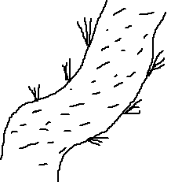
____________________ ____________________
- How do Christians show love for others?
________________________________________________
- How do we call the town where Jesus was born?
________________________________________________
- Write things used during baptism.
________________________________________________

- Draw these places of worship.

- Give any two miracles Jesus performed.
- ________________________________________________
- ________________________________________________
- Mention things done at the place of worship.
(i)_______________________(ii)_________________________
- Give one importance of religious leaders.
________________________________________________
- How do we care for God’s creation?
- ________________________________________________
- ________________________________________________
- Write two roles of children in a home.
- ________________________________________________
- ________________________________________________
- Why did Jesus die on the cross?
________________________________________________
- What makes man different from other creatures?
________________________________________________
- Give any two ways of cleaning our body.
- ________________________________________________
- ________________________________________________
- What do these names mean?
Jesus________________________________________________
Moses________________________________________________
- Draw these needy people.
the elderly | the blind

- How do people meet their needs?
________________________________________________
- Name the person who betrayed Jesus.
________________________________________________
- Give any two things we pray for.
- ________________________________________________
- ________________________________________________
- Mention any two things we pray for.
- ________________________________________________
- ________________________________________________
- Match the body part to their functions.
ears tasting
tongue touching
hands hearing
- How do we call the prayer Jesus taught us?
________________________________________________
- What took place on the following days?
Easter ________________________________________________
Palm Sunday _________________________________________
Christmas ____________________________________________
- Name these symbols of Christianity.
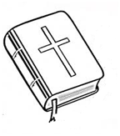
_________________ _________________
- Write any two important animals.
- ________________________________________________
- ________________________________________________
- Who taught us the Lords’ prayer?
________________________________________________
- How did Jesus show his love to people?
________________________________________________

