**A**

**B**

**T**

**TRINITY PRIMARY SCHOOL-BUKOTO**

**REVISION WORK**

**P.5- MATHEMATICS**

**Time: 2hrs 30 min**

**NAME: __________________________________STREAM: ______**

**SECTION A (20 QUESTIONS - 40 MARKS)**

1. Work out: 2 3

+ 1 2

1. Write three hundred forty eight in figures.

1. Simplify 2b + 5b

1. Given that set B= {all vowel letters}.Find the number of elements in set B.

1. What time is shown on the clock face below?

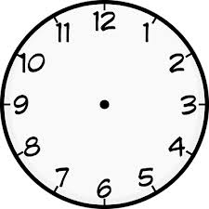

1. ­­­­­­­­­­­­­­­­­­­­­­­­Given that (1 kg = 1000 kg).Convert 7 kilogrammes to grammes.

1. Work out; 2 488
2. **[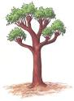](http://www.google.co.ug/imgres?imgurl=http://static.howstuffworks.com/gif/how-to-plant-trees-shrubs-and-vines-47.jpg&imgrefurl=http://home.howstuffworks.com/how-to-plant-trees-shrubs-and-vines.htm/printable&usg=__31g4FePvFyp2Ike9SCXjQDYnnSc=&h=411&w=300&sz=26&hl=en&start=8&zoom=1&tbnid=y7Jd2Lvct2Kb1M:&tbnh=125&tbnw=91&ei=MuBsTZm1MoqIhQfTuLyRDA&prev=/images?q=trees&hl=en&sa=G&gbv=2&tbs=isch:1&itbs=1)** Given that = 5 trees. How many trees are represented by ?

1. List down all the factors of 8.

­­­­­­­­­­­­­­­

1. Find the missing part of the fractions below.

$\frac{1}{2}$ = $\frac{}{6}$

1. Given that m= 6 and n=4.Work out the value of m + n.
2. Change 2 hours to minutes.

1. Work out: Shs: 1500

- Shs: 700

1. Name the figure below.

15. On the Venn diagram, shade K ∩ L.

K L

16. Write number 7348 in expanded form.

17. Julius ate $\frac{3}{11}$ of the sugar cane in the morning and $\frac{4}{11}$ in the evening. What fraction of the sugarcane was eaten altogether?

18. Calculate the area of the figure below.

5cm

6cm

19. Calculate the value of the unknown angle.

300

x

20. Okello bought a book at shs. 700 and sold it at shs.1000.How much profit did he get after selling the book?

**SECTION B (12 QUESTIONS 60MARKS)**

21. Given that set **A**= {x, y, z, w, p}

**B** = {w, m, p, d, y}

a) Represent the above information on the Venn diagram below.

**A B**

b) What are the members in

(i) A ∩ B

(ii) How many elements are in AuB?

22. Bosco went to the market and bought the following items.

|  |  |
| --- | --- |
| **Item** | **Price** |
| Book  A ruler  Mathematical set  A pencil | Shs. 1000  Shs.500  Shs.1500  Shs.200 |

1. What was the cheapest item?
2. Find the total cost of two mathematical sets.
3. Work out the cost of all items shown on the shopping list.

23. Work out:

(a) Hours Minutes

4 40

+ 2 40

(b) Covert 3 weeks to days.

(c)How many days are in the mouth of February of a leap year?

24. Study the diagram below and answer questions that follow.

p

1. Name the shape above.

5cm

x

10cm

1. Find the value of;
2. x
3. p
4. Work out the total distance around the figure above.

25. (a) Add:

(b) Arrange $\frac{5}{8}, \frac{3}{8}, \frac{6}{8}, \frac{1}{ 8}$ starting with the smallest.

(c) How many halves make two wholes?

26. Add: (a) 2 3 9 (b) 3 0 2

+ 2 4 2 x 4

(c) Marata had 27 eggs. He gave 13 eggs to his grandmother. How many eggs did he remain with?

27. Work out the following correctly.

1. X 3 = 12 (c) 3 + = 15
2. - 7 = 5 (d) ÷ 2 = 4

28. Given the number 4832.

(a) What is the place value of 3 in the number above?

(b)Represent the number above on the abacus below.

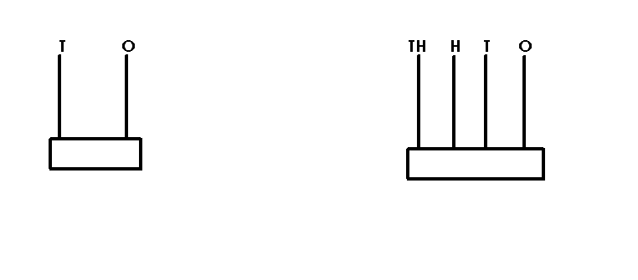

1. Which number has been expanded to give 2000+ 400 +3?

29. (a) List down the first 2 multiples of 7.

(b) Find the lowest common multiple of 4 and 6.

(c) Find the sum of the first three odd numbers.

30. Subtract:

(a) Litres Millitres

1 7 2 7

- 1 2 1 2

(b) Change 3 metres to centimetres.

(c) James had 36 litres of water and they used 27 litres at home. How many litres of water did he remain with?

31. Study the diagram below and answer the questions that follow.

**E**

**D**

**O**

**A**

**B**

1. Name the figure above.
2. Name the lines marked with letters;
3. ED
4. OC
5. If line OC is 7cm. Calculate the length of the line AB.

32. Complete the table below.

|  |  |
| --- | --- |
| **Tally marks** | **Number** |
|  | ______ |
| **______** | 13 |
|  | _____ |
| **______** | 20 |
|  | _____ |

**END**