SECTION | MARKS
A
B
TOTAL
TRINITY PRIMARY SCHOOL – BUKOTO
REVISION WORK
CLASS : P.4
LEARNING AREA : MATHEMATICS
Name: ________________________________ Stream:________
Date: __________________________________________________
SECTION A
- Add: 3 + 2 + 4 =

- Find the next number in the sequence.
0, 5, 10, 15, ______, ______
- Use a number line to work out.
2 X 3 =

0 1 2 3 4 5 6 7 8 9
- Shade AuB on the venn diagram.
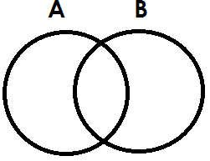
- Express xv in Hindu Arabic numerals.

- Write the unshared fraction.

- If represents 4 cylinders. How many cylinders are represented by?

- Name this shape.
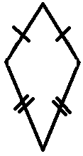
- Multiply 2 4
X 2

- Work out: shs 7 0 0
-shs 2 5 0

- Write 940 in words.

- Name this set.
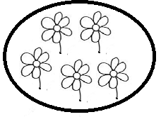A set of ____________________________
- Mary ate $\frac{2}{10}$ of the cake in the morning and $\frac{4}{10}$ in the afternoon. What fraction did she eat altogether?

- How many days are in a fort night?

- Work out: H T O
4 2 3
+ 1 7

- Find the perimeter of the triangle below.

6cm 5cm

9cm
- Simplify the like terms.
m + m + m = _________

- Find the value 7 in 271.

- Use “greater than” or “less than” to compare the fractions.

$\frac{1}{2}$ is _____________________ than $\frac{1}{4}$
- Which number comes just before 29?

SECTION B
- (a) Expand 19.

(b) Which number is shown on the abacus?
H T O

(c) Find the place value of 6 in 604.

- (a) Add: m cm
4 20
+3 10

(b) Calculate the area of the rectangle below.

4cm

6cm
- Use the venn diagram to answer the questions.
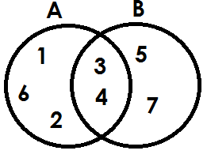
- List the members of;
- Set A

- Set AnB

- Set AuB

- How many members are in set B?

- Complete the magic square below.
c | d | 5
b | 4 | 6
3 | a | 1

- (a) Add $\frac{2}{11}$ + $\frac{4}{11}$ + $\frac{1}{11}$

(b) Namugga ate $\frac{1}{4}$ of a chapatti. What fraction remained?

- The containers A and B have water. Use the containers A and B to answer the questions correctly.
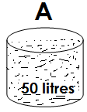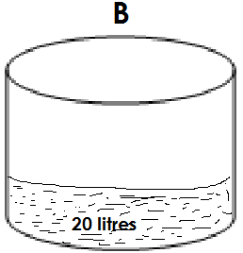
- Which container is bigger?

- Which container has more water?

- If all water in container A is poured in container B, how many litres of water will be in container B?

- (a) How many triangles can you see?

(b) Draw these shapes.
trapezium | cone

- The table below shows the price list in Mr. Barigye’s shop. Use it to answer the questions.
Item | Price
A book  A pencil  An egg  A bar of soap  A kg of rice  a pen | Shs 700  Shs 200  Shs 400  Shs 800  Shs 1000  Shs 500
- How much is the cost of a book and a pencil?

- How much is the cheapest item?

- Find the total cost of a pen, a book and a bar of soap altogether?
- (a) What time is sown on the clock face?
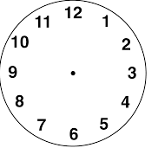

It is _____________________
- A teacher started teaching at 8 o’clock and stopped at 10 o’clock. How long did he spend teaching?

- Change 2 hours to minutes.

- (a) Find the missing number.
- - 6 = 4
- + 8 = 15
(b) Tom is 6 years old. Paul is 9 years old. Find their total age.

- (a) Share 36 bananas equally among Ritah and Luke. How many bananas does each get?

(b) Kato has 29 pens. Musa has 32 pens,
(i) How many pens do they have altogether?

(ii) How many more pens does Musa have than Kato?

- The graph below shows the number of cars counted by Juma on Saturday.

- How many white cars did he count?

- Which colour has the least number of cars?

- Find the total number of cars that Juma counted in Saturday.

