TRINITY PRIMARY SCHOOL – BUKOTO
SECTION | MARKS
A
B
TOTAL
REVISION WORK
CLASS : P.3
LEARNING AREA : ENGLISH
Name: ______________________________
Date: _______________________________
Fill in the missing letters.

- tab___e
- umb___ella
- tra___n
- g___n

Write the sentences correctly.
- meat cooks he everyday.
______________________________________________________
- three brothers has she.
______________________________________________________
- sick people a doctor treats.
______________________________________________________
- trees are they cutting.
______________________________________________________
Use “is”, “are “or “am” to complete the sentences.
- The girl __________________ not in class.
- Our nurses __________________ in the sickbay.
- I __________________ learning literacy.
Complete the sentences using the correct form of the word in brackets.
- Our baby is __________________ an egg. (eat)
- She __________________ teeth every morning. (brush)
- Marvin ________________ his homework yesterday. (do)
- Ketrah is __________________ than Sasha. (short)
- Catherine is a __________________.(teach)
Arrange in ABC order.
- train , bus , aeroplane , ship
______________________________________________________
- brush , basket , box , bed
______________________________________________________
Give the plural of the underlined words.
- His child is very sick.
______________________________________________________
- My mother has a big knife.
______________________________________________________
- His dog has a puppy.
______________________________________________________
- My mother is washing her dress.
______________________________________________________
Form a small word from a big word.
- teacher ____________________________________
- carpenter ____________________________________
- policeman ____________________________________
Make sentences using the given words.
- two: ________________________________________________
- to: _________________________________________________
Study the picture and complete the sentences correctly.
- 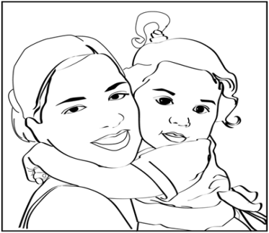She is __________________ the baby.
- 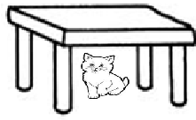The cat is _______________ the table.
- 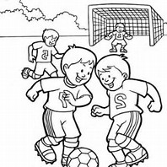The boys are ________________ football.
Find the odd man out.
- apple, matooke, orange, mango
___________________________________________________
- bus, car, lorry, sheep
___________________________________________________
- blue, leaf, pink, green
___________________________________________________
- pig, cow, goat, lion
___________________________________________________
Give one word for the underlined group of words.
- I met a man who treats sick people.
___________________________________________________
- My mother brought oranges, pineapples and apples.
___________________________________________________
Re-write as instructed in brackets.
- They got an accident. The driver was carless. (Join using:…..because….)
___________________________________________________
- That is the man. He had a gun. (Join using:…who…)
___________________________________________________
- He planted maize. He planted beans. (Join using:….and……)
___________________________________________________
- She washed her face. She did not wash the legs. (Join using:…but……)
___________________________________________________

SECTION B
- Read the story and answer the questions that follow in full sentences.

Hunger in the village
Once upon a time, the cock and the leopard were great friends. They lived in a village called Bukinda. One day, hunger came. The leopard decided to eat the cock. The cock ran to an old woman called Kanori. The old woman gave it a big basket. The cock stayed in the big basket until there was a lot of food again.

Questions
- Who were great friends?
__________________________________________________
- Where did they live?
__________________________________________________
- Who decided to eat the cock?
__________________________________________________
- Where did the cock ran to?
__________________________________________________
- Write the title of the story.
__________________________________________________
- Study the table and answer the questions.

Days of the week | Position
Sunday  Monday  Tuesday  Wednesday  Thursday  Friday  Saturday | first  second  third  fourth  fifth  sixth  seventh

Questions
- How many days make a week?
__________________________________________________
- What is the first day of the week?
__________________________________________________
- How many days start with letter T?
__________________________________________________
- Write the last day of the week.
__________________________________________________
- Give Wed in full.
__________________________________________________
- Study the pictures and answer the questions.
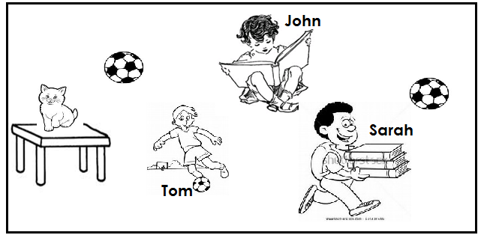
Questions
- Who is playing football?
__________________________________________________
- What is Sarah carrying?
__________________________________________________
- Who is reading a book?
__________________________________________________
- How many balls are in the pictures?
__________________________________________________
- Where is the cat?
__________________________________________________

- Match animals to their young ones.
dog calf
sheep baby
cow kitten
man puppy
cat lamb
- Fill in correctly.
- A person who treat sick people is a ______________.
- A ___________________ teaches children.
- A ___________________ makes furniture.
- A ___________________ keeps law and order.
- A farmer grows ___________________.

- Use the given words to complete the story.

died , man , snake , well , water

One morning, Timothy was going to fetch ___________________ from the ___________________. He saw a very big black ___________________ slithering towards him. He screamed and called neighbours to come and kill it. The ___________________ man came running and hit it on the head. It ___________________.

