SECTION | MARKS
A
B
TOTAL
TRINITY PRIMARY AND PRESCHOOL
REVISION WORK
CLASS : P.1
SUBJECT : R.E
Name:________________________________________
Date: ________________________________________
SECTION A
- Write your Religious name. _______________________________________
- Who created all the people on earth?( Adam, God) _____________________________________________________
- Give one importance of a father in a home. ____________________________________________________
- Circle the thing used to clean the body.

table sponge

- Name the symbol below for Christians. (cross, holy spirit)
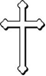

- Write one thing God created. ________________________________________________________
- What name is given to the Christian place of worship?
(church, mosque) ________________________________________________________
- Write any one need of a family. ________________________________________________________
- What is the meaning of the name Peter? ________________________________________________________
- Give one way we care for our bodies. ________________________________________________________
- Draw and name one animal God created.

- Name one group of people found at school. _______________________________________________________
- What is the name of the creation shown below?
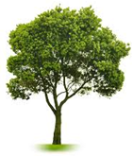

________________________________________________________________
- How can children show respect to elders? __________________________________________________
- Which animal was created by God to give people security at home? (cow, dog) ________________________________________________________
- Name any one member of a nuclear family. (father, maid) _____________________________________________________
- How useful is the sun to people? (it burns people, it give light to people) _______________________________________________________
- Who leads prayers in the church? (Imam, priest) ________________________________________________________
- How many disciples did Jesus have? ________________________________________________________
- Give one role of a child at home? ______________________________________________________

SECTION B
- (a)Mention two domestic animals God created. (i)__________________________ (ii)______________________
(b)Give two animals that give us milk. (i)________________________ (ii)_______________________
22. Match the following body parts.
leg

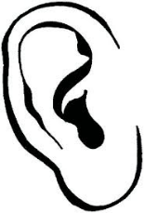
eye

nose
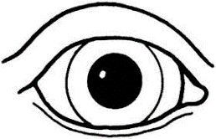

ear

- (a) Circle the following people found at school.
Bursar, cobbler, pupils, farmer, teachers
(b) Name the person who cares for sick pupils at school. ___________________________________________________
24. (a)Draw these things which God created to give us light.
sun | stars | the moon
(b) Who was the wife of Adam? (Esther, Mary, Eve) __________________________________________
25. Write two fruit trees God created. (i)__________________________ (ii)_______________________
(b) Give two uses of fruits to people. (i)________________________________________________________(ii)________________________________________________________
26. Tick the Christian names for girls.

Eve | Esther | Moses | Timothy
Jacob | Stella | Bosco. | Mary

- Which body part do we use when;
Clapping? __________________________________________________
Singing? ___________________________________________________
reading the bible? __________________________________________
walking? ____________________________________________________
- Give four people found at home.
(i)________________________ _________________________________
(ii)_________________________________________________________
iii)_________________________________________________________
(iv)_________________________________________________________
(doctor, father, baby, matron, brother, nurse, mother)

- On which days do these people go for prayers?
Christians __________________________________________________
Moslems __________________________________________________
(b) Name these things used by people to worship God. (dictionary, rosary, Bible, necklace)
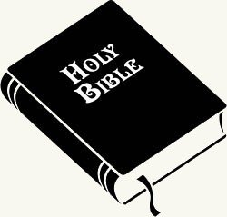 | 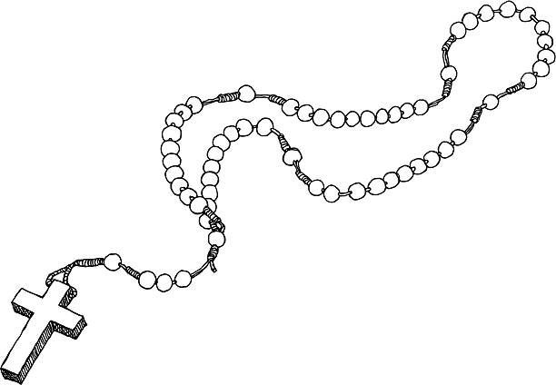

30. Draw these things used to clean the body.

sponge | water | towel | soap

- (a) Mention any two needy in the community. (i)_________________________ (ii)_________________________
(b) Give two ways of helping the needy people. (i)_____________________________________________________
(ii)_____________________________________________________

32. (a) Write roles of these people at school.
(i)Head teacher ______________________________________
(ii)gate man ___________________________________________
(b) Who takes care of pupils in the dorm? (cooks, matron) __________________________________________________________
(c) Give one way children can show respect at school. _______________________________________________________
33. (a) How are these things useful in the church
(i) candle __________________________________________________
(ii) Bible ___________________________________________________
(iii) chairs ___________________________________________________
(b) Why do people go to church? __________________________________________________________
34.(a) give the roles of these people in a family.
Father __________________________________________________
Mother __________________________________________________
(b) Circle our relatives.
uncle, teacher, matron, grand mother
35.(a) How do we care for domestic animals? (i)___________________________________________________________
(ii)___________________________________________________________
(b) Tick the animals which are used for transport.
dog, horse, lion, camel
END

