TRINITY PRIMARY SCHOOL-BUKOTO
For examiner’s use only
A
B
TOTAL
REVISION WORK
CLASS: P.4
LEARNING AREA: RELIGIOUS EDUCATION
TIME ALLOWED: 2HOURS

Name __________________________________________Stream __________
SECTION A: 40 MARKS
1. Who died on the cross for our sins?
___________________________________________________________
2. What does the name Peter mean?
_____________________________________________________________
3. Name this Christian symbol.
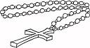
_____________________________________________________
4. Whom did God command to build the Ark?
_____________________________________________________________
5. Who is the grandfather of all believers?
_____________________________________________________________
6. What should a Christian do after sinning?
_____________________________________________________________
7. Name the king who wanted to kill baby Jesus.
_____________________________________________________________
8. What do we call the fasting period of Christians? _____________________________________________________________
9. Why do people greet others?
_____________________________________________________________
10. Name the person who received the Ten Commandments.
____________________________________________________________
11. Draw and name any one living thing God created.

12. Who was the wife of Abraham?
___________________________________________________________
13. Who led the Israelites out to the Promised Land?
_____________________________________________________________
14. How many days do Christians fast?
____________________________________________________________
15. What did God create on the last day?
_____________________________________________________________
16. How do people worship God?
____________________________________________________________
17. What happened on Christmas day?
_____________________________________________________________
18. Which creature tempted Eve in the Garden of Eden?
____________________________________________________________
19. Who sent the Holy Spirit to the disciples? ____________________________________________________________
20. Name the main source of light created by God.
____________________________________________________________
SECTION B: 60 MARKS
21. (a) Name any two gifts God gave you on your body.
(i)_______________________ (ii)________________________
(b) Draw and name the gifts God gave us for;
(i) walking | (ii) seeing

22. Match correctly
Judas Iscariot killed Abel
Cain betrayed Jesus
Noah earthly father of Jesus
Joseph built the ark
23. (a) Name these symbols.
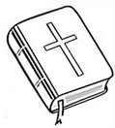 | 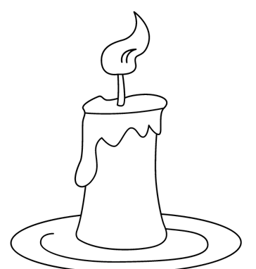 | 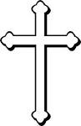

(b) Why do Christians go to Church on Sunday?
____________________________________________________________
24. (a) Name two groups of people who are needy.
(i) _____________________________________________________________
(ii) ____________________________________________________________
(b) Mention any two Ways you can show care to the needy.
(i) ____________________________________________________________
(ii)___________________________________________________________
25. a) What is prayer?
___________________________________________________________
b) Write down any two types of prayers.
- __________________________________________________________
ii) __________________________________________________________
c) On which day do Christians go for general prayers?
___________________________________________________________
27. (a) Identify two roles of a mother at home.
- _________________________________________________________
- _______________________________________________________
(b) State any two activities you can do at home as a good child.
(i)________________________________________________________
(ii)_______________________________________________________
28. (a) ________________________________is a messenger of God.
- Mention any two prophets in the Bible.
(i) ________________________________________________ (ii)________________________________________________
(c) What do we call a prayer Jesus taught his disciples?
_________________________________________________
29. (a)Name these places of worship.
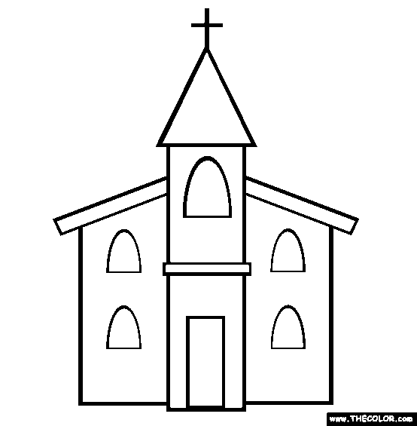 | 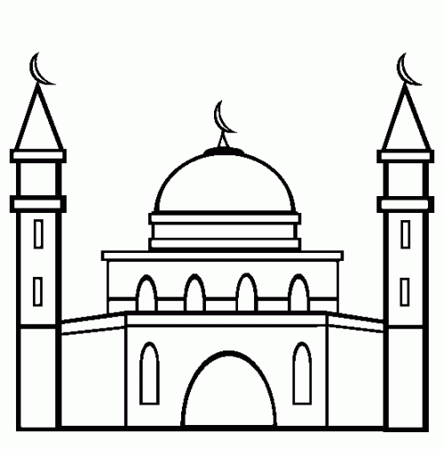
(b) Draw and name any two items found in the church.

29. Write what you know about these people
(i)Mary___________________________________________________
(ii)Joseph ________________________________________________
- Priest _______________________________________________
- John the Baptist ______________________________________
30. Fill in the missing parts in the prayer (The Grace) below
‘May the Grace of our Lord _______________________ and the love of _____________and the fellowship of the ______________ be with us all, now and forever more, _______________________’.
31.(a) Name the first two people to be created by God (i)______________________ (ii) __________________________
b) In which garden did God put the first people he created?
_______________________________________________________
(c) How did Adam and Eve disobey God?
_________________________________________________________
32. (a) Name the river where Jesus was baptized
__________________________________________________________
(b) People are baptized in the name of the ___________________ and of the _____________________ and of the Holy Spirit.
(c) Name the bird in the diagram below.
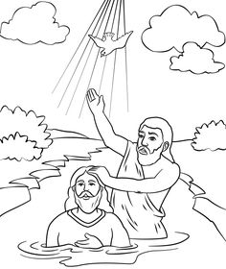

__________________________
33. (a) Why did Jesus die on the cross?
________________________________________________________
(b) On which day do we remember the death of Jesus?
_______________________________________________________
- State any one miracle performed by Jesus.
____________________________________________________
- Name any one apostle of Jesus.
______________________________________________________
34.(a) Write any two qualities of a good leader. (i)_______________________________________________ ii)_______________________________________________
- Write down any two leaders at school.
i)_____________________________________________________
ii) _____________________________________________________
35. (a) What is worshipping?
__________________________________________________________
(b)Mention any two ways how God communicated to people?
- ____________________________________________________
(ii)____________________________________________________
(c) The child kneeling in the diagram below is in church.
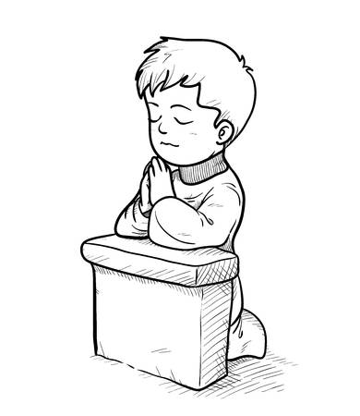
What is he doing?

__________________________________________________________________________

End

