For examiner’s use only
A
B
TOTAL
TRINITY PRIMARY SCHOOL-BUKOTO
REVISION WORK
CLASS: P.3
LEARNING AREA: RELIGIOUS EDUCATION
TIME ALLOWED: 2HOURS 15 MINUTES

Name __________________________________________Stream __________
SECTION A
- Who is the creator of heaven and earth?
_____________________________________________________________
- On which day of the week do Moslems go for general prayers?
____________________________________________________________
- Write any one example of a religious Christian name.
____________________________________________________________
- Give any one importance of the sun to people.
____________________________________________________________
- What symbol of God’s family washes away the original sin from a person?
____________________________________________________________
- Name one person who preaches in this place of worship.
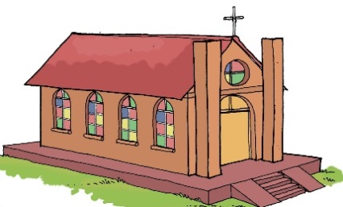

- How do you respect your friend in Primary two?
_______________________________________________________
- What was the work of Joseph the earthly father of Jesus?
______________________________________________________
- Which disciple denied Jesus Christ three times?
______________________________________________________
- Who is the only son of God who died for our sins.
_________________________________________________________
- Name the Holy book used by priests.
__________________________________________________________
- Mention any one animal which give us meat and milk.
_________________________________________________________
- Give any one use of water to people.
___________________________________________________________
- Draw a rosary in the space below.

- Mention one leader in the church.
________________________________________________________
- Name any one type of family.
_________________________________________________________
- How can a Christian worship God?
__________________________________________________________
- What lesson do you learn from the coming of Jesus Christ in the world?
___________________________________________________________
- Draw and name any two materials you can use to keep your body clean.

- Underline the day Jesus was born
Christmas day, Good Friday, Holy Thursday, Easter Monday

SECTION B: (60 MARKS)
- Match the following sense organs to their uses correctly.
- Tongue For feeling
- Eyes For hearing
- Skin For tasting
- Ears For sight

- (a)Name these living things God created.
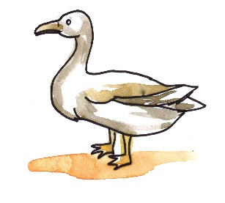 | 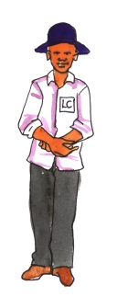
(b)Name any two things we find in the church
(i)___________________________________________________
(ii)___________________________________________________
- State the work of the following people at school.
- Security guard ______________________________________
- Matrons _______________________________________________
- School nurse ___________________________________________
- Teacher ________________________________________________
- (a)Name any two plants which are a source of food to people.
(i)_________________________________________________________
(ii)_________________________________________________________
(b) Name these sources of water which God created for us.
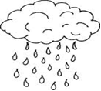

- (a)Mention the two part of the Holy Bible.
- ______________________________ testament
- ______________________________testament
(b)Name nay two books in the Bible
(i) _______________________ (ii) __________________________
- a) Who heads a family?
__________________________________________________________
b) Name three groups of people who make up a nuclear family.
(i)_________________ (ii) ________________ (iii) _____________
- a) Write any two gifts you can give to your friend.
(i) ___________________________ (ii) _____________________
b) Identify two gifts that God gave you.
(i) __________________________ (ii) __________________________
- Match correctly.
Grandfather daughter of my mother.
Sister children of my aunt.
Uncle father of my father.
Cousins brother of my mother.
- (a) Why are children baptised?
________________________________________________________
(b)Name the person who baptizes people in the church
_________________________________________________________
(b) Name two things used during baptism.
(i) ________________________________ (ii) _______________________
- (a)Name two things God created to give us light.
(i) ________________________________ (ii) _______________________
(b) Write two animals used for transport.
  - _____________________________________________________
  - ______________________________________________________

- (a)Name these important places in our community.

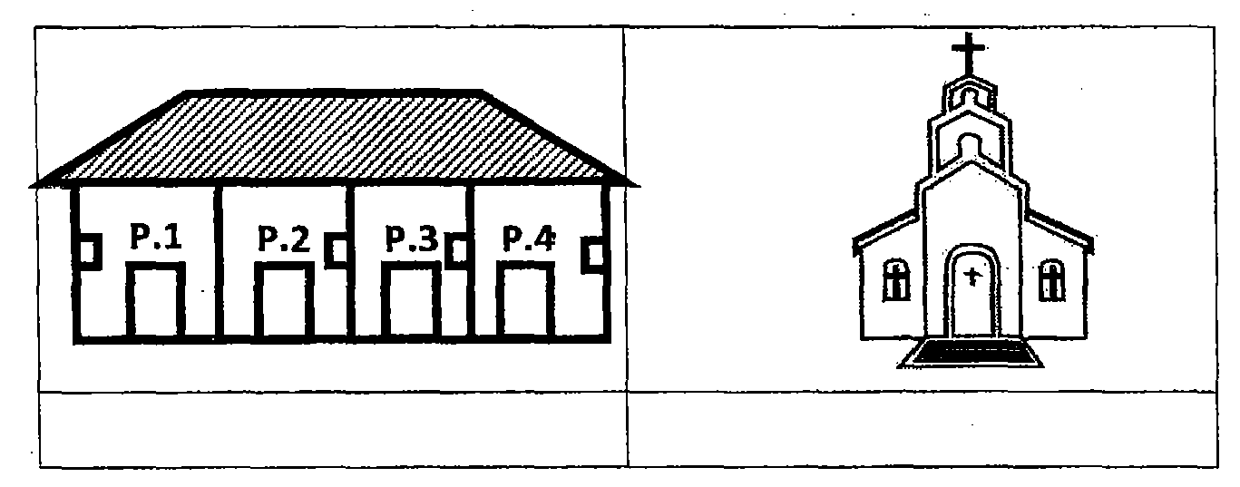
(b) Mention two activities Christians do when they go to church
i.________________________________________________________
ii.________________________________________________________
- (a)Mention two things people did to welcome Jesus.
i. ________________________________________________________
ii._________________________________________________________
(b) Give any two apostles of Jesus.
i._______________________________________________________
ii. ________________________________________________________
- (a)Write any two miracles Jesus performed
- ____________________________________________________
- ____________________________________________________
(b) Answer true or false
(i) Simon Peter betrayed Jesus _____________________________
(ii)John doubted Jesus ____________________________________

- (a)Match correctly.
A. B
Mary mother of John the Baptist
Elizabeth. Mother of Jesus

(b) Which event took place on the following days?
a) Christmas day. __________________________
b) Easter. __________________________

35. (a) Mention any two roles of a mother in a family
(i)______________________________________________________________
(ii)____________________________________________________________
(b) Name these people who need help.
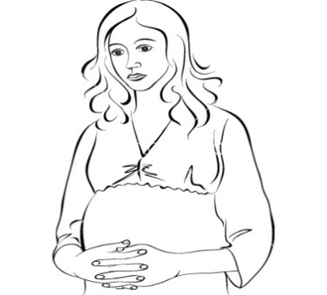 | 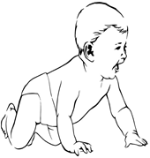

END

