TRINITY PRIMARY SCHOOL-BUKOTO
For examiner’s use only
A
B
TOTAL
REVISION WORK
CLASS: P.3
LEARNING AREA: LITERACY
TIME ALLOWED: 2HOURS 15 MINUTES

Name __________________________________________Stream __________

SECTION A 40MARKS
- Name one thing found in a classroom.
_______________________________________________________
- Mention one room found in a house.
________________________________________________________
- How is a clock useful in a classroom?
________________________________________________________
- Name this important place in a community.
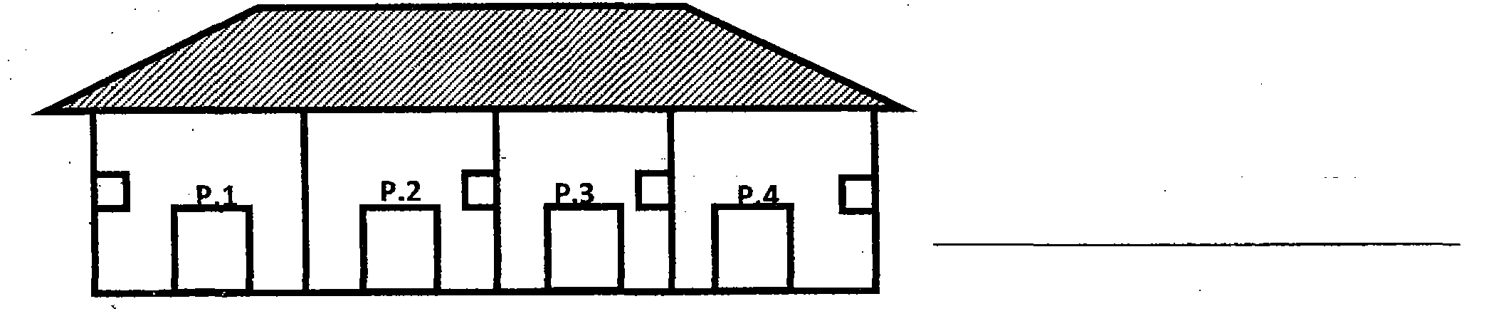

- Why do we keep cows at home?
_________________________________________________________
- Mention one activity done by children at school.
_______________________________________________________
- Who breast feeds a baby at home?
______________________________________________________
- Name any one person found in a nuclear family.
_______________________________________________________

- Why do we need doctors in a community?
_____________________________________________________
- Draw and name any one play object found in our school.

- How do people care for plants in their homes?
___________________________________________________
- Who heads a school?
____________________________________________________
- Which people keep security at school?
____________________________________________________
- Name one bird kept at home.
_______________________________________________________
- Give one use of a house.
_____________________________________________________
- Write the name of your school.
________________________________________________________
- Draw these things we find in the dining room.
plate | spoon

- Write one important person who works in a hospital.
_________________________________________________
- Name these things made by a carpenter.
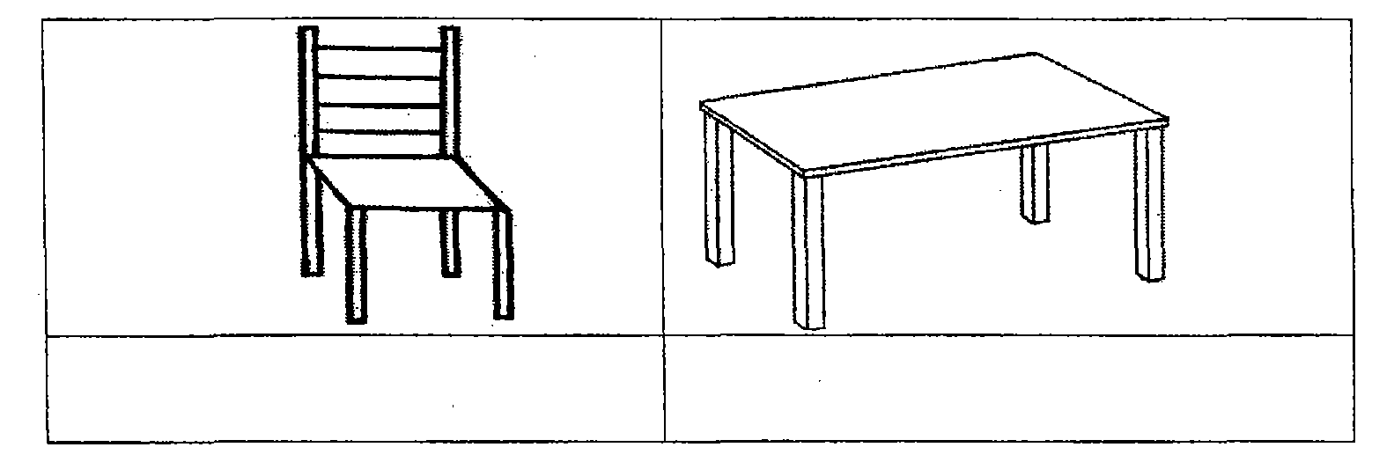
- Name the item we use for sweeping.
_______________________________________________________

SECTION B (60 marks)

- Match correctly.
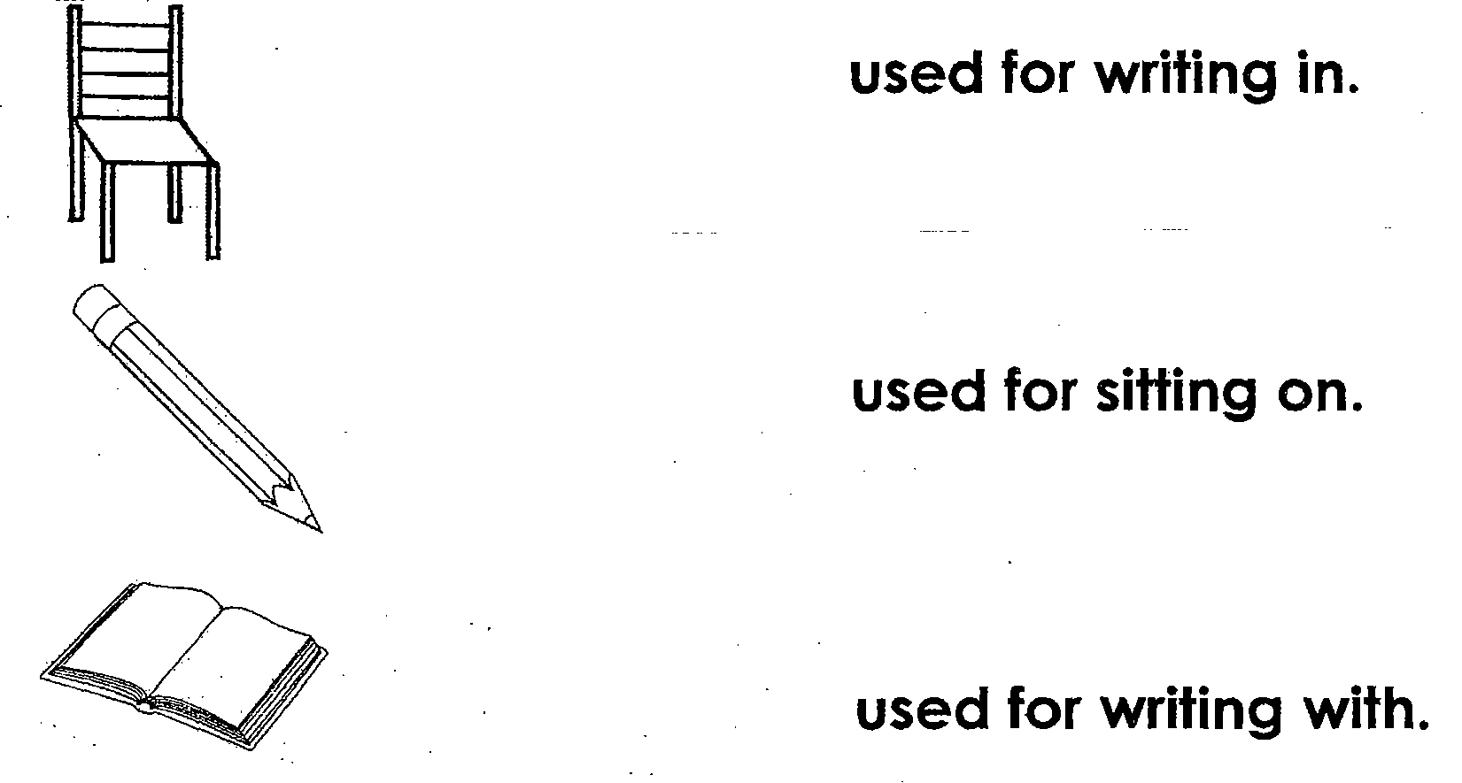
- (a) Name two types of weather.
  - ________________________________________________
(ii) ________________________________________________
- Write two things we can use on a rainy day.
- ________________________________________________
(ii)_________________________________________________
- (a) Give two common diseases at school.
  - ____________________________________________
  - ____________________________________________
(b) Write two insects which spread diseases to people.
(i) __________________________________________________
(ii) __________________________________________________
- (a) Name these uses of water at home.
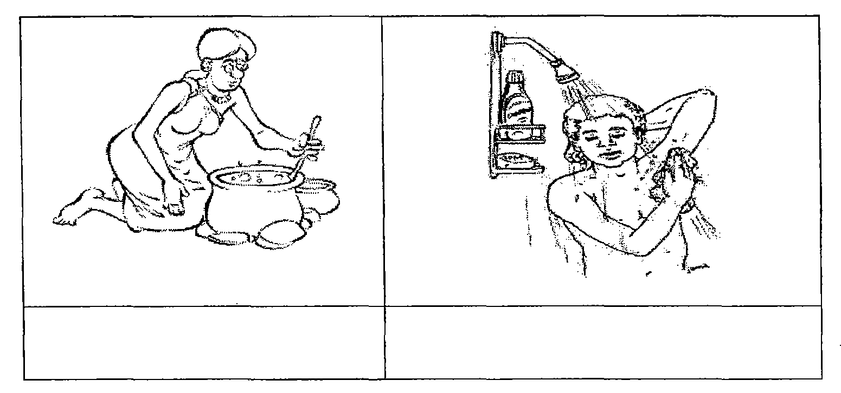
(b)Draw these road signs.
Parking | Zebra crossing

- Match correctly.
Item Made from
pot hides
chair palm leaves
mat wood
bag clay
- (a)How many legs do these animals have?
  - Sheep ___________________________________
  - Duck ____________________________________
(b) How do these animals move?
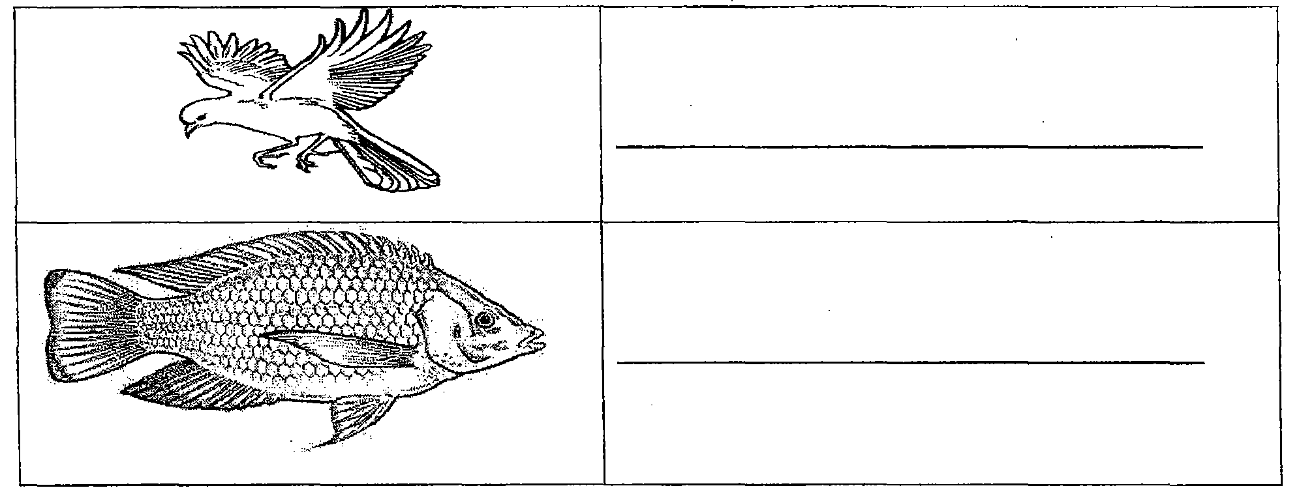

- (a) How can you keep these parts of the body
clean?
  - teeth ______________________________________
  - hands _____________________________________
(b) Give one use of the following;
  - eyes _______________________________________
  - nose _______________________________________
- (a) Name the parts of the house.
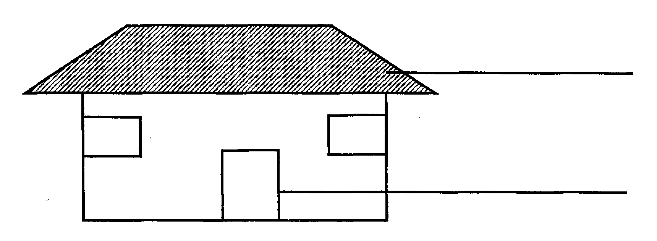
(b) Write two things people use to build houses.
(i) ____________________________________________
(ii) ____________________________________________
- (a) Name two plants people grow in the garden.
(i) _________________________________________________
(ii) _________________________________________________
(b) Name this part of a plant.
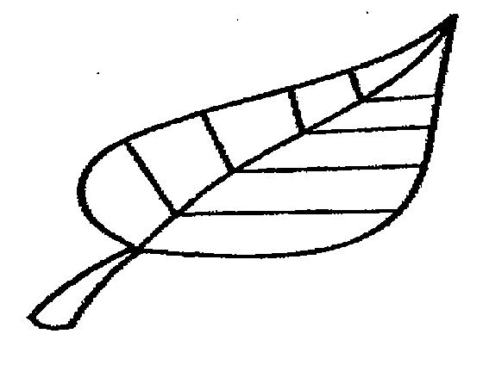_____________________________
(b) How are plants useful to people?
_____________________________________________________
- (a) Name these wild animals
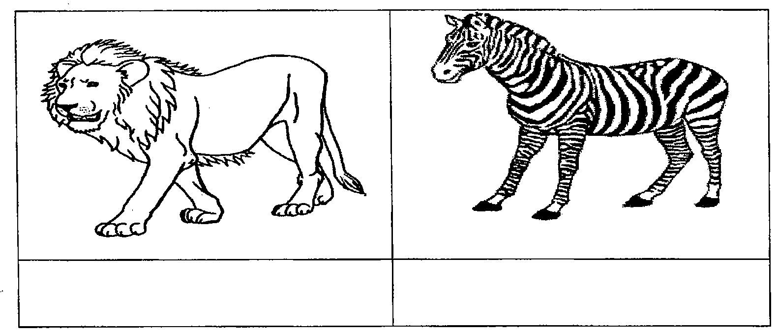
(b) How are wild animals dangerous to people?
____________________________________________________
(c) Write one place where wild animals live.
_____________________________________________________
- (a)Name these things found in a home.
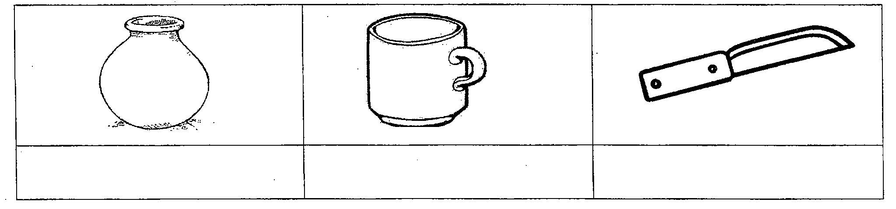
(b) Why do we need a knife at home?
______________________________________________________
- Match correctly.
People place of work
Head teacher sickbay
Cooks classroom
Nurse office
Librarian kitchen
Teacher library
- (a)Write two foods we eat at school.
(i) ___________________________________
(ii)___________________________________
(b) Write two important people who work in a school
(i)______________________________________ (ii)________________________________________
- (a)How do children help their parents at home?
  - __________________________________________
  - __________________________________________
(b) Write two activities children can do in the field.
(i)_______________________________________________
(ii)________________________________________________
- (a) Draw the building materials below.
Nails | Bricks | Iron sheets

(b) Write two activities done by people in a community.
(i)____________________________________________________
(ii) ___________________________________________________

