TRINITY PRIMARY SCHOOL-BUKOTO
REVISION WORK
CLASS: P.2
LEARNING AREA: LITERACY
TIME ALLOWED: 2HOURS

Name ________________________________Stream __________
SECTION A: 40MARKS
- Name the garden tool used for digging.
_____________________________________________________
- Apart from a cat, name any one other domestic animal. ______________________________________________________
- Circle the two things found in the bedroom.
bed chair blanket bench
- Name this symbol of a school

_________________________________

- Mention any one material you use to clean your classroom.
________________________________________________________
- Draw these things used to manage rainy weather
Umbrella | Gumboots

- Who heads a family? _______________________________________________________
- Mention any two materials we use in a bathroom.
(i)___________________________(ii) ___________________________
- Name these animals which transport people.
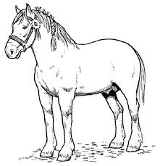 | 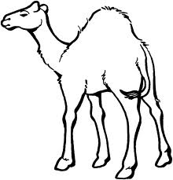

- Give one example of food eaten without cooking it.
______________________________________________________
- Write any one building found in a school.
_______________________________________________________
- Name these things found in our classroom.
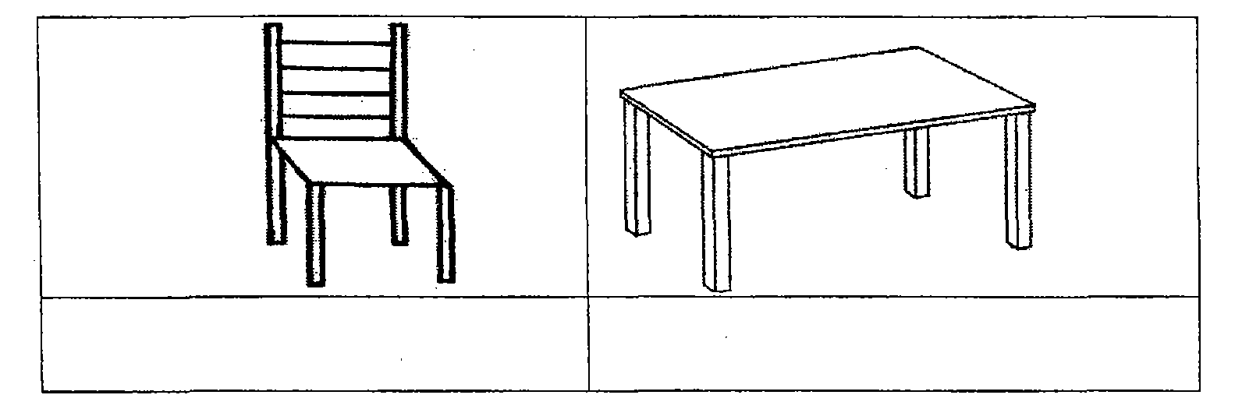

- Write down any one element of weather.
_____________________________________________________
- Mention any one role of a mother at home.
______________________________________________________
- Why do we eat food?
________________________________________________________
SECTION B: 60MARKS
- Name these parts of the body.
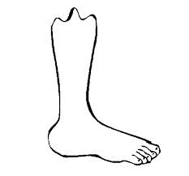 ___________________________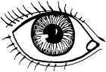_______________________
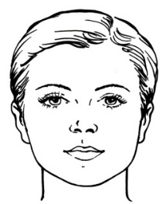___________________________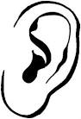_____________________________
- (a)What are wild animals?
________________________________________________________________________________________________________________________
(b)Give three examples of wild animals.
- __________________________________________________
- __________________________________________________
- _________________________________________________

- (a) Name these activities done in the community.
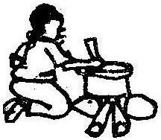
_________________ ______________________
(b) Mention any two activities done by children at school.
  - ____________________________________________
  - ____________________________________________
- (a)Name the two types of family.
(i)_______________________ (ii)___________________
(b)Name one person we find in;
(i) a nuclear family ____________________________________
(ii)an extended family __________________________________
- Name these parts of a house
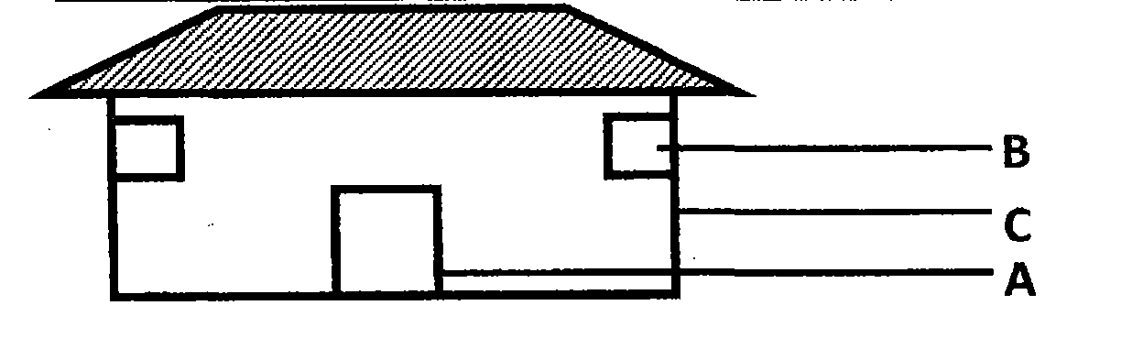
- Match correctly.
eggs carbohydrates
cassava vitamins
oranges proteins
- Draw these means of transport.
aeroplane | car
- Name the animals that give us.
- eggs:_______________________________________________
- milk:_______________________________________________
- Give the use of the following;
(i) eyes________________________________________________
(ii) nose ______________________________________________
- Name these basic needs of people.
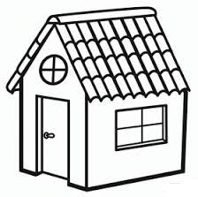_______________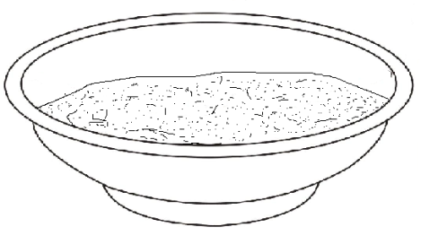___________
END

