|  |  |
| --- | --- |
| **SECTION** | **MARKS** |
| **A** |  |
| **B** |  |
| **TOTAL** |  |

**TRINITY PRIMARY SCHOOL-BUKOTO**

**REVISION WORK**

**CLASS : P.1**

**SUBJECT : R.MATHEMATICS**

**Name:_______________________________________**

**Date: ________________________________________**

1. **Add: 2 + 3 =___________________**
2. **Name this set.**

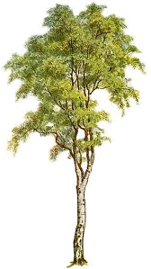

1. 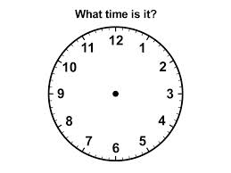**What time is shown on the clock face?**

**IIt is ___________________O’clock.**

1. **Fill in the missing number.**

**1, 2, 3, 4, ____, 5, ____, 7, 8.**

1. **Write in words.**

**3 __________________________________**

**7 _________________________________**

1. **Name this shape. (Circle, square, triangle)**

**______________________**

1. **Use longer or shorter.**

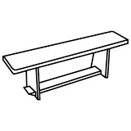**Bench A**

** Bench B**

**Bench A is ______________________ than Bench B**

1. **Add correctly.**

**4 books**

**+3 books**

1. **Study the graph and answer the questions correctly.**

**John Peter**

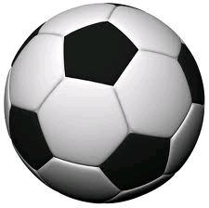

**Who has more balls? ________________________________________**

1. **How many days are in a week? __________________________________________**
2. **Circle the smaller number.**

**25 , 10**

1. **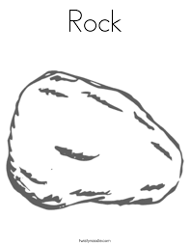****Stone M stone N**

**Which stone is lighter? ____________________________________________________**

1. **Draw the bundles for the number**

**25 =**

1. **Find the missing number.**

**7 + = 10**

1. **Draw the set.**

**A set of 3 apples.**

1. **Draw a circle.**
2. **Eight balls take away three balls equals ____________________________________**
3. **Find the number**

**+ 5 = 8**

1. **Subtract:**

**7 - 3 =___________**

1. **Which number cones after?**

**8, _________**

**SECTION B: 60MARKS**

1. **Write the missing days of the week.**

**Sunday,__________________, Tuesday, __________________**

**Wednesday, _____________________.**

**b) ___________________ is the first day of the week.**

1. **Use more / less**

**Set Y set Z**

1. **Set A has __________________ members.**
2. **Which set has more members? ____________________________________________**
3. **How many members are there in set Y and set Z altogether? ____________________________________________**
4. **a) Show the number on the abacus.**

**T**

**O**

**24 =**

**b) Write the number shown on the abacus.**

**T**

**O**

1. **a) Name this shape. (cone, oval, Rectangle)**

**_________________________**

**b) How many sides does the above figure have? ________________________________________________**

1. **Pot A and pot B have water.**

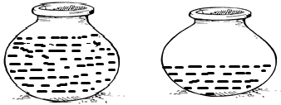

**A**

**B**

1. **Which pot has more water? ___________________________________________**
2. **Pot ____________________ has less water.**
3. **Find the missing number.**
4. **+ 6 =10**
5. **6 + = 1**
6. **Match correctly.**

**5 + 3 = 5**

**9 – 4 = 12**

**2 x 6 = 8**

1. **Form small sets from a big set.**

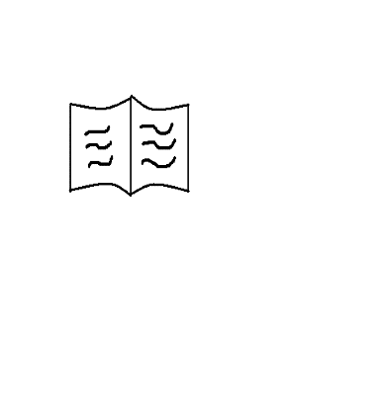







1. **Use the numberline to work out.**

**3 + 2 =_________________**

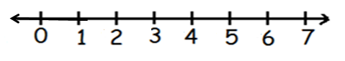

**6 – 4 =______________________**



1. **Draw these shapes.**

|  |  |
| --- | --- |
|  |  |
| **Oval** | **square** |

1. **Count in twos.**

**0, 2, 4, 6, ________, _________**

1. **Study the graph and answer the following questions.**

|  |  |
| --- | --- |
| **Mary** |  |
| **Sarah** |  |
| **Tom** |  |
| **John** |  |

**Number of apples children ate.**

1. **How many apples did Sarah eat? ________________________________________**
2. **Who ate more apples? ____________________________________**
3. **____________ and ____________ ate the same number of apples.**
4. **How many aples did they eat altogether? _________________________________________**

**END**