|  |  |
| --- | --- |
| **SECTION** | **MARKS** |
| **A** |  |
| **B** |  |
| **TOTAL** |  |

**TRINITY PRIMARY AND PRESCHOOL**

**REVISION WORK**

**­CLASS : P.1**

**SUBJECT : ENGLISH**

**Name:_______________________________________**

**Date: ________________________________________**

1. **Fill in the missing letters.**

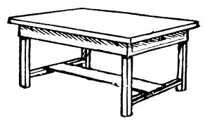

t______ble

c____p

1. **Fill in a or an.**

**It is ________ egg.**

**Pat has _______ bag.**

**________ elephant has big ears.**

**That is ______ pot.**

1. **Write these words in capital letters.**

**tree __________________________**

**mat ___________________________**

1. **Name the pictures.**

|  |  |
| --- | --- |
|  |  |
|  |  |

1. **Give the plural of the underlined words.**

**I have a red flower. ________________________________________**

**Can I have a ruler please? ________________________________________**

**The book is in the box. _________________________________________**

**The baby is crying. _________________________________________**

1. **Answer Yes, it is or No, it is not**

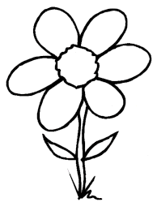**Is this a chalkboard?**

________________________________

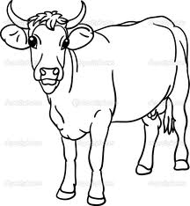**Is this a cow?**

_________________________________

1. **Form a small word from a big one.**

**teacher _____________________**

**classroom ___________________**

1. **Write the sentence correctly.**

**book is This a. __________________________________________**

**your name What is? ___________________________________________**

**playing She is. ____________________________________________**

1. **Arrange in ABC order.**

**k, a, p, b ____________________________________________**

**cat, fish, eggs ___________________________________________**

1. **Make a sentence using these words.**

**sitting: ___________________________________________**

**eating: __________________________________________**

**SECTION B**

1. **Read the conversation and answer the questions in full.**

**Paul: Good morning Dan**

**Dan: Good morning Paul**

**Paul: His your new class?**

**Dan: Primary one class is good. There are chairs**

**tables**, **pencils, colours and story books in my**

**class.**

**Paul: Oh! That’s good. Who is your class teacher?**

**Dan: My class teacher is Mrs. Ddamba.**

**Questions**

1. **How many people are talking? ___________________________________________**
2. **In which class is Dan? ____________________________________________**
3. **Who talked first? _____________________________________________**
4. **Draw and name two things in Dan’s class.**

|  |  |
| --- | --- |
|  |  |
|  |  |

1. **(a) March correctly.**

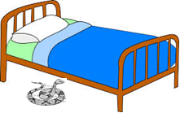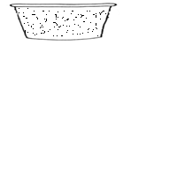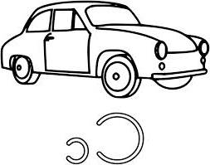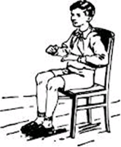

**The snake is under my bed.**

**The tin is near the car.**

**He is sitting on the chair.**

**There is water in the basin .**

**b) Who am I?**

**I live at home**

**My youngone is a calf**

**I give people meat and nilk**

**I have four legs**

**Who am I?**

**You are a _______________________________**

1. **Make five sentences from the table.**

|  |  |  |
| --- | --- | --- |
| **They**  **I**  **Mary**  **He** | **am**  **is**  **are** | **going to school**  **playing football**  **cooking food** |

1. **______________________________________________**
2. **______________________________________________**
3. **______________________________________________**
4. **______________________________________________**
5. **______________________________________________**
6. **Read and draw.**

|  |  |
| --- | --- |
| **A ball and a tree** | **She is sweeping** |
|  |  |

1. **Re arrange the sentences to make a good story.**
2. **I buy food and ice cream.**
3. **Every Saturday, I go for shopping.**
4. **Then I go back home.**
5. **________________________________________________**
6. **________________________________________________**
7. **_________________________________________________**
8. **Use the words in the box to complete the story.**

|  |
| --- |
| **Dress, bible, church, chair, shoes** |

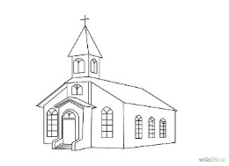

**My name is Joan. I go to ____________**

**every Sunday.**

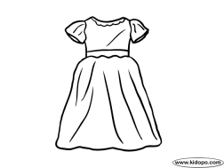

**I put on my white ________________________**

[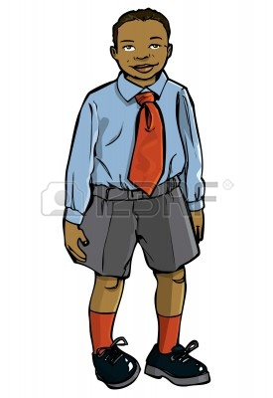](http://us.123rf.com/400wm/400/400/antonbrand/antonbrand1104/antonbrand110400233/9334802-cartoon-boy-in-school-uniform-isolated-on-white.jpg)**and black ___________________________.**

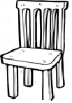

**When I reach church, I sit on the ______________**

**and read my ___________________.**

**end**