TRINITY PRIMARY SCHOOL- BUKOTO
REVISION WORK
CLASS: P.1
SUBJECT: LITERACY
NAME: _____________________________________ STREAM: _____________
- Name any two things you wear.
(i)____________________________ (ii)___________________________
- Mention any two body parts.
(i)____________________________ (ii)___________________________
- Circle the things we use in the classroom.
soil bench grass desk
- Name these dangerous objects.
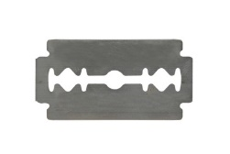__________________ 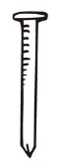_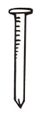_______________
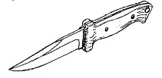________________________________
(nails, razorblade, knife)
- Tick the ways of caring for your body parts.
- by sweeping
- by bathing
- by digging
- by washing
- Mention any two members of an extended family.
(i)water ___________________________________________________ (ii)soap_____________________________________________________
- Name these types of weather.
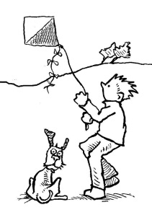
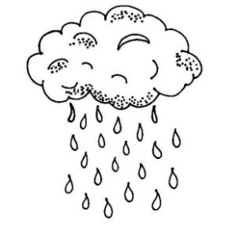

________________ ___________________ __________________

- Name these materials we use to keep our body clean.
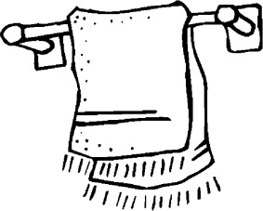 _________________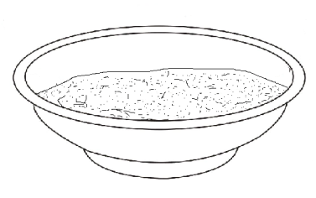___________________________________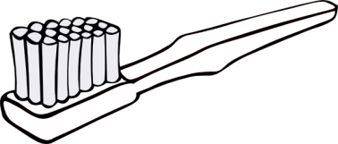_________________
(tooth brush, sponge, water, towel)
- List any two things which fly in air.
(i)__________________________ (ii)___________________________
- List any two animals which live in water.
(i)______________________________ (ii)___________________________
- Name this animal.
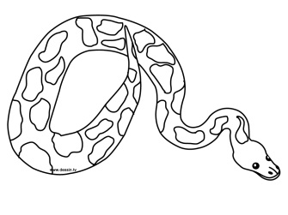____________________________________

- Match the sense to its organ.
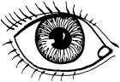 hearing
tasting
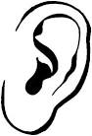 seeing
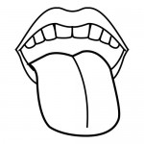 smelling

- Name these examples of houses.
___________ 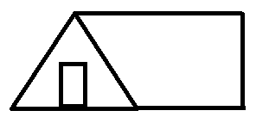___________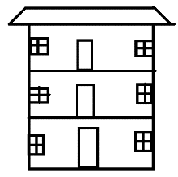__________
(tent, flat, hut)

- (a) On 8th March every year, we celebrate women’s day in Uganda. Colour the mother below.
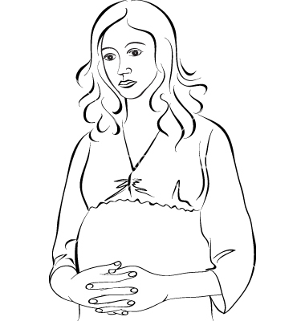

(b) Give any four roles of a mother in a home.
(i) _____________________________________________________________
(ii)______________________________________________________________
(iii) _____________________________________________________________
(iv) _____________________________________________________________

End

