**TRINITY PRIMARY SCHOOL-BUKOTO**

**NATURE OF WORK: REVISION WORK**

**SET: 5**

**SUBJECT: SCIENCE**

**CLASS: P.4**

**NAME: ______________________________ DATE ___________**

**SECTION A (40MARKS)**

1. Name **one** example of a wild animal.

**……………………………………………………………………………………….................**

2. How useful are ears on a human body?

**……………………………………………………………………………………….................**

3. In the space below, draw a child suffering from polio.

4. Give **one** reason why we should wash our hands after visiting the toilet.

**………………………………………………………………………………………................**

5. Give **one** example of energy giving food.

**………………………………………………………………………………………................**

6. State **one** use of the sun to man.

**……………………………………………………………………………………….................**

7. How are plants useful to animals?

**……………………………………………………………………………………….................**

8. Mention the type of soil that is best for modeling.

**………………………………………………………………………………………..................**

9. State the importance of the object below.



**......................................................................................................................................**.

10. What do fish use for breathing?

**………………………………………………………………………………………..............**

11. Identify the type of clouds that provides man with rainfall.

**………………………………………………………………………………………...............**...

12. Name the weapon that the animal below uses for protection.

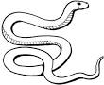

**……………………………………………………………………………………….................**

13. State any **one** use of a fire extinguisher.

**………………………………………………………………………………………...............**

14. Name any **one** source of water in a community.

**………………………………………………………………………………………...............**

15. How are shadows formed?

**………………………………………………………………………………………..........**

16. Draw and name any one garden tool that can be used for transplanting.

**...........................................................**

17. What is weeding?

**……………………………………………………………………………………….................**

18. Give **one** reason why we should give first aid to casualties.

**………………………………………………………………………………………...............**

19. State **one** reason why animals move.

**……………………………………………………………………………………….................**

20. Write down any **one** way of keeping food safe for a long time without going bad.

**………………………………………………………………………………………..................**

21. How do farmers control soil erosion in the garden?

**........................................................................................................................................**

22. Name any **one** plant that grows well in swamps.

**……………………………………………………………………………………….............**.....

1. State **one** way how we can control AIDS.

**………………………………………………………………………………………..........** ....**....**

1. Write **one** item that is used to harvest rain water.

**………………………………………………………………………………………..................**

1. Give **one** use of plants in a school compound.

**………………………………………………………………………………………..................**

1. Write down any **one** agent of soil erosion.

**………………………………………………………………………………………..................**

1. State **one** condition a seed needs to germinate.

**……………………………………………………………………………………….................**

1. Give **one** difference between animals and plants.

**………………………………………………………………………………………................**

1. State **one** way how people care for their domestic animals.

**……………………………………………………………………………………….................**

1. Name this type of weather.

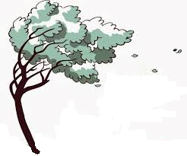

**……………………………………………………………………………………….................**

31. What name is given to a young lion?

**……………………………………………………………………………………….................**

32. Give **one** bad eating habit.

**………………………………………………………………………………………..................**

33. Mention **one** way a housefly is different from a spider.

**………………………………………………………………………………………..................**

34. State **one** reason why we brush our teeth.

**………………………………………………………………………………………..................**

35. Why does a chameleon change its colour according to the environment?

**………………………………………………………………………………………..................**

36. State any **one** importance of a dustbin.

**………………………………………………………………………………………..................**

37. Which food value do we get from this animal below?

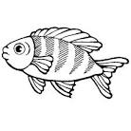**………………………………………………………………………………………..................**

38. Give **one** example of germs.

**………………………………………………………………………………………..................**

39. Mention the insect that spread germs which cause sleeping sickness.

**………………………………………………………………………………………..................**

40. Write down any **one** item used to clean our body.

**………………………………………………………………………………………..................**

41. (a) What is mulching?

**........................................................................................................................................**

(b) Name **one** material used for mulching the garden.

**........................................................................................................................................**

(c) Give **one** importance of mulching.

**.………………………………………………………………………………………...............**

(d) Give **one** danger of mulches in the garden.

**.......................................................................................................................................**

42. (a) Define the term soil.

**…………………………………………………………………………………….....................**

(b) Identify **two** types of soil.

(i)**...........................................................**  (ii)**...................................................................**

(c) Which type of soil is always mixed with cement when building houses?

**........................................................................................................................................**

43. (a) What is a vector?

**………………………………………………………………………………………...................**

(b) Mention **two** examples of vectors.

(i).............................................................. (ii)..................................................................

(c) State **one** way of controlling vectors.

**..........................................................................................................................................**

44. (a) Give **one** reason why a cow is a living thing.

**………………………………………………………………………………………....................** (b) Identify any **one** importance of cows to people.

**…………………………………………………………………………………….......................**

(c) How does a cow protect itself from enemies?

**..........................................................................................................................................**

(d) A calf is to an elephant as a .............................................................is to dog.

45. (a) How do we call the mixture of gases?

............................................................................................................................................

(b) What property of air is drawn below?

..................................................................................

(c) Write down any **one** components of air.

**……………………………………………………………………………………..**

(d) Which part of air occupies the largest percent in atmosphere?

..........................................................................................................................................

46. **The diagram below shows a plant. Use it to answer the following questions.**

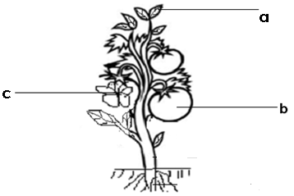**d**

(a) Name the part marked with **d**.

**………………………………………………………………………………………....................**

(b) State any **one** use of part **a** to the plant.

**………………………………………………………………………………………....................**

(c) Give any **one** use of plants to people.

. **…………………………………………………………………………………….........**

(d) Mention **one** use of animals to plants.

..........................................................................................................................................

47. **Study the diagram below and answer questions that follow.**



1. Name the layer marked

(i) A ....................................................... (ii) C..............................................................

b) Why is layer A best for growing crops?

..........................................**………………………………………..........................................**

c) What do we call the arrangement of soil layers as shown above?

**………………………………………………………………………………………....................**

48. **Study the insects below and fill in the table correctly.**

|  |  |
| --- | --- |
| Insects with three stages of growth | Insects with four stages of growth |
| 1. ___________________________ 2. ____________________________ | (i)___________________________  (ii)___________________________ |

(Housefly, cockroach, tsetse fly, butterfly)

49. How is each of the following people useful to a community?

(i)Dentist**…………………………………………………………………………….**

(ii) Farmer**……………………………………………………………………………**

(iii) Veterinary officer**………………………………………………………………..**

(iv) Doctor**……………………………………………………………………………**

50. a) Name the parts of an insect below.

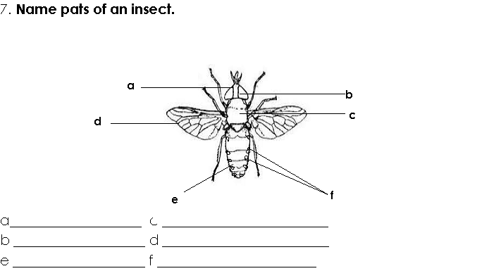

1. a.................................................. (ii) c .................................................................

(iii) d......................................................................

b) How important is part marked **f** to an insect?

...........................................................................................................................................

51. **Use the diagram below and answer questions that follow.**



1. Name the process taking place at;
2. A......................................................................
3. B......................................................................
4. What is the use of the sun in the process shown above?

..............................................................................................................................................

1. State any **one** danger of too much rain.

**.......................................................................................................................................**

52. **Match the following correctly.**

|  |  |
| --- | --- |
| 1. Ticks 2. House fly 3. Female infected anopheles mosquito 4. Dogs | Trachoma  Malaria  Rabies  Typhus fever |

1. Ticks ..........................................................................................................................
2. Housefly.....................................................................................................................
3. Female infected anopheles mosquito........................................................................
4. Dog...............................................................................................................................

53. a) Identify what is eaten in these plants.

(i) Mango ................................................................................................................

(ii) Beans...........................................................................................................................

(iii) Cabbage .....................................................................................................................

(iv) Cassava.....................................................................................................................

54. a) What is first aid?

**………………………………………………………………………………………...................**

b) Identify any **two** things used to give first aid.

(i)**……………………………………………………………………………………..................**

(ii)**……………………………………………………………………………………** .................

c) State any **one** reason why we should give first aid.

**………………………………………………………………………………………....................**

55. a) Name the main natural source of light.

............................................................................................................................................

b) State any **one** danger of too much sun shine.

...........................................................................................................................................

1. Give any **two** uses of the sun to people.

(i).........................................................................................................................................

(ii).........................................................................................................................................

END