TRINITY PRIMARY SCHOOL- BUKOTO
REVISION WORK
CLASS: P.3
SUBJECT: RE
Name: …………………………………………....…..Stream: ……………….
- Name these places of worship.
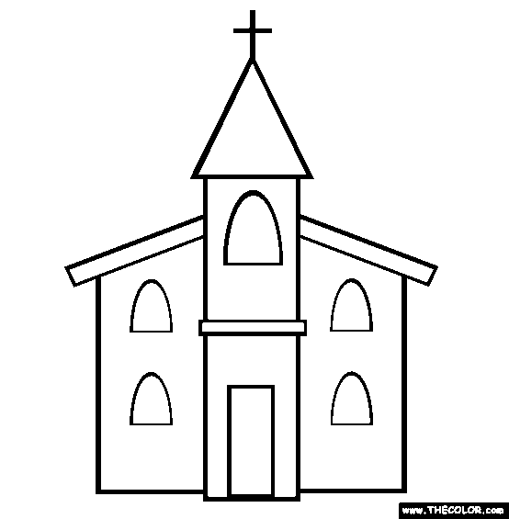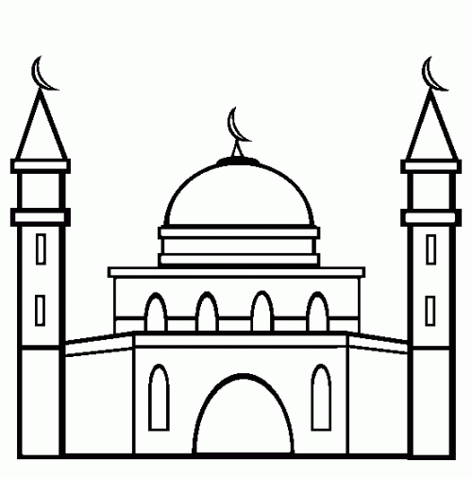
______________________ _________________________
- (a) Mention any three examples of people who baptize people in churches.
(i)_____________________________ (ii)_______________________________
(iv)_____________________________
(b) In the space provide below, draw a priest baptizing a baby.

- (a) Who died for our sins? ____________________________________________
- State any two examples of sins
(i)____________________________________________________
(ii)____________________________________________________
- What name is given to the holy book for________________________
- Match names to their meanings.
Peter God is with us
Deborah rock
Emmanuel cheater
Isaac bee
Jacob laughter
- Who was the father of all believers?
________________________________________________________________
- In the space below, draw and shade Jesus on the cross

- List any three gospel books.
(i)__________________(ii)___________________(iii)_____________________
- Draw these things God created.
sun | lakes | rivers
birds | plants
(b) How is the sun important to people.
___________________________________________________________________
- Who was the wife of Adam?
___________________________________________________________________
- Who climbed a sycamore tree to see Jesus?
___________________________________________________________________
- Match these correctly.
Judas Iscariot baptized Jesus
Jesus the father of all believers
John the Baptist betrayed Jesus
Abraham died for our sins
- God created us with senses. Mention the senses which these sense organs do.
- nose _______________________________________________________
- ear _________________________________________________________
- skin _______________________________________________________
- tongue ____________________________________________________
- (a) Who is a Christian?
___________________________________________________________________
(b) Give one importance of a Bible to a Christian.
___________________________________________________________________
- a) What are customs?
______________________________________________________________________
b) Give any two examples of traditional customs in our society.
i)__________________________________________________________________
ii) ______________________________________________________________
15. Mention any two groups of people who teach us customs.
i)_______________________________ ii) ________________________________
16. Name any two books in the New Testament.
(i)___________________________ (ii)____________________________
- Draw and name any two animals which live in water.

- Draw the following needs of a community.
clothing | shelter | food

- God created water for us, name any three uses of water to people.
(i)___________________________________________________________
(ii)___________________________________________________________
(iii)___________________________________________________________
- Name any two commandments of God.
(i)_____________________________________________________________
(ii)_____________________________________________________________

……………….END……………….

