TRINITY PRIMARY SCHOOL-BUKOTO
REVISION WORK
CLASS: P.2
SUBJECT: RE
Name: ___________________________________________ Stream: _____________
- Who is our father in heaven? ________________________________________________________________________
- How do Christians become members of God’s family? ________________________________________________________________________
- Who was the earthly father of Jesus? ________________________________________________________________________
- How did Jesus show love to us? ________________________________________________________________________
- How long did God take to create the world? ________________________________________________________________________
- Who was the first man to be created? ________________________________________________________________________
- How did the apostles help Jesus to do his work? ________________________________________________________________________
- How do we talk to God? ________________________________________________________________________
- What was the first miracle Jesus performed? ________________________________________________________________________
- Who is the head of a family? ________________________________________________________________________
- Why did God create light? ________________________________________________________________________
- What is the Holy book for Christians? ________________________________________________________________________
- Why did Jesus die on the cross? _______________________________________________________________________
- Give the name of the river where Jesus was baptized. ______________________________________________________________________
- Name these sources of water.
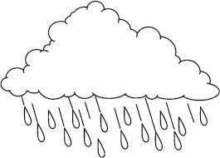

- Write any three uses of water to man.
- ____________________________________________________________________
- ____________________________________________________________________
- ___________________________________________________________________
- Mention any three harmful insects to us.

- _____________________________
- ____________________________
(iii)__________________________

- Why do people pray, give three reasons?
- ____________________________________________________________
- ___________________________________________________________
- ___________________________________________________________
- Give any three needy people.
- _____________________________________________________
- _____________________________________________________
(iii) _____________________________________________________
- Mention any two ways of helping the needy.
- __________________________________________________________________
- __________________________________________________________________
- Name the church symbols.
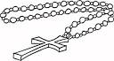 | 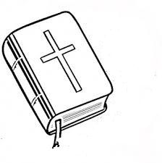 | 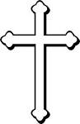

- Mention any three activities done in the church.
- __________________________________________________________________
- _________________________________________________________________
- ________________________________________________________________
- Give any two examples of plants.
- ___________________________ (ii) _____________________________

- Match organs to senses.
nose feeling
tongue smelling
skin tasting
- Mention any three disciples of Jesus.
- _________________________________ (ii) ___________________________
(iii) ________________________________
- Give two ways in which Jesus showed love to the people.
- __________________________________________________________________
- _________________________________________________________________
- Give any three leaders in church.
- ______________________________ (ii) _______________________________
(iii) ___________________________________
- Draw these places of worship.
church | mosque

End

