TRINITY PRIMARY SCHOOL- BUKOTO
Revision work
Class: P.1
Subject: RE
NAME: ___________________________ STREAM: ________
- Who created heaven and earth?
____________________________________________________________
- Write any two religious names for girls.
(i) __________________________(ii)___________________________
- _________________________ is the holy book for Christians.
- Who was the earthly father of Jesus Christ?
____________________________________________________________
- Draw these things God created.
sun | moon | star | hill
- Write the name of Adam’s wife. (Mary, Eve)
_____________________________________________________________
- Who was the mother of Jesus?
____________________________________________________________
- On which day do Christians go to church? (Friday, Sunday)
____________________________________________________________

- A place where Christians go for prayers is called a _____________
(mosque, church)

- Match these names with their meaning.
Emmanuel mankind
Jesus battle
Peter peace
Adam God with us
Hilda saviour
Irene rock

- Write the uses of these body parts.
- legs___________________________________________________
- tongue________________________________________________
- ears___________________________________________________
- nose___________________________________________________
- eyes___________________________________________________
- Write the uses of these things that God created.
- sun______________________________________________________
- plants____________________________________________________
- water____________________________________________________
- fire _____________________________________________________
- Who is the short man who climbed the sycamore tree to see Jesus?
____________________________________________________________
(Peter, Zaccheaus)
- Match the senses with their body parts.
nose seeing
ear feeling
eye tasting
skin smelling
tongue hearing
- Name these symbols.
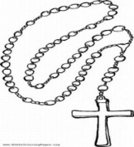 | 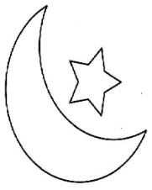 | 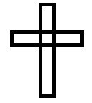

- Draw these things we use to clean our body.
basin | water | sponge | soap | razorblade

- Give any three wild animals God created.
- _______________________________
- _______________________________
- _______________________________

- Draw these things made by man to give us light.
torch | fire | candle | lamp

- What is a home?
____________________________________________________________
- Name any two people who start a home.
- _______________________________
- _______________________________
- Write three importance of parents in a home.
- _________________________________________________________
- _______________________________________________________
- _______________________________________________________
- What is your religious name?
____________________________________________________________
- Give any two things found in the church.
- _______________________________
- _______________________________

END

