TRINITY PRIMARY SCHOOL- BUKOTO
REVISION WORK
P.7- INTEGRATED SCIENCE

Time: 2hrs 15 min
NAME: __________________________________STREAM: ______

SECTION A.
- Name any one component of blood in the body.
__________________________________________________________________
- State one importance of bathing our bodies daily.
__________________________________________________________________
- Which system of poultry keeping is commonly practiced in rural (village) areas?
__________________________________________________________________
- State any one method used to clean clothes at home.
__________________________________________________________________
- How is the sun important to people in their daily life?
__________________________________________________________________
- Give any one example of a renewable resource in the environment.
_________________________________________________________________
- Write down one method used to harvest cassava tubers from the garden.
__________________________________________________________________
- Suggest one reason why people rear dairy breeds of cattle.
__________________________________________________________________
- Which member of a nuclear family is responsible for breast feeding a baby in a home?
____________________________________________________________________
- Why is a goat called a mammal?
____________________________________________________________________
- State any one advantage of breast feeding to a baby.
_____________________________________________________________________
- Give any one danger of poor sanitation in a home.
__________________________________________________________________

- Why is a cockroach considered as a vector?
_____________________________________________________________________
- Find the volume of an irregular object in the diagram below.

__________________________________________________________________
- Write down any one example of a chemical change.
__________________________________________________________________
- In which one way are flowers useful to people?
__________________________________________________________________
- Name the reproductive cell drawn below.

__________________________________________________________________
- State one way how communicable diseases spread from one person to another.
__________________________________________________________________
- Mention one effect of tobacco smoking to an individual.
__________________________________________________________________
- How are dry banana fibres useful to people in our community?
_______________________________________________________________

- Identify any one way of improving soil fertility.
__________________________________________________________________
- In the space provided below, draw a compound trifoliate leaf.

- How are domestic animals important to people in a home?
__________________________________________________________________
- Suggest one way of keeping a healthy working condition of the human lungs.
__________________________________________________________________
- Which type of weather is managed by wearing light clothes?
__________________________________________________________________
- Give any one example of a cereal crop.
__________________________________________________________________
The diagram below is a blood vessel. Use it to answer question 27.
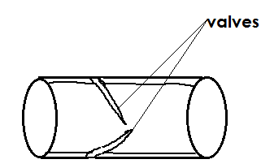
- Identify the type of blood vessel drawn above.
__________________________________________________________________
- State one danger of fungi to people in our environment.
__________________________________________________________________
- Mention one method used to control crop pests in the garden.
__________________________________________________________________
- Identify any one musical instrument played by beating.
__________________________________________________________________

- Give any one product obtained from sheep.
__________________________________________________________________
- 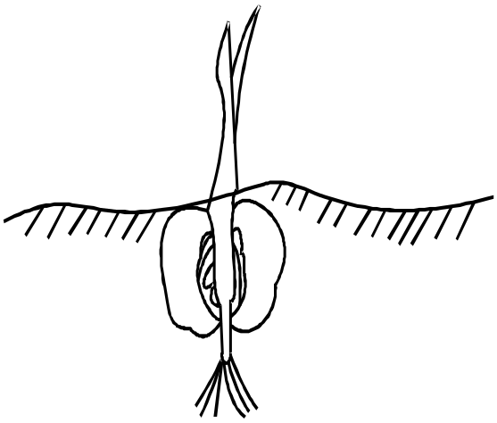Name the type of germination shown in the diagram below.

__________________________________________________________________
- Identify any example of a flightless bird.
_________________________________________________________________
- In which state of matter does heat travel fastest?
__________________________________________________________________
- State any one activity done by a P.6 pupil before eating food.
_________________________________________________________________
- Suggest one way how filtration method is applied in our daily life at home.
__________________________________________________________________
- Why is a spider not considered to be a true insect?
__________________________________________________________________
- State one way of preventing burns and scalds at home.
__________________________________________________________________
- By what process does heat travel through solid materials like metals?
__________________________________________________________________
- Give any one example of an external cattle parasite.
__________________________________________________________________

SECTION B. (60 marks)
- (a) Name the main organ of the respiratory system.
__________________________________________________________________
(b)Identify any two diseases that affect the respiratory system.
(i) ________________________________________________________________
(ii)________________________________________________________________
(c) Which component of air is used in the body during the process of respiration?
__________________________________________________________________
42. (a) Write down one activity done to promote the following elements of PHC.
(i) Personal hygiene __________________________________________________
(ii) Food and nutrition _________________________________________________
(b) State two roles of family members in promoting sanitation at home.
(i) __________________________________________________________________
(ii)___________________________________________________________________
- The diagram below is an onion. Use it to answer questions.
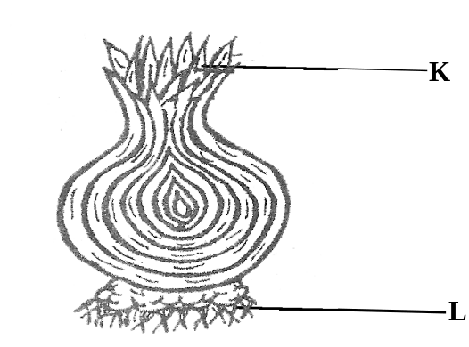
V

- Name the parts marked V and L.
(i)V______________________________ (ii) L_____________________________
- How is part “V” useful to the plant?
__________________________________________________________________
- To which group of underground stems does an onion belong?
__________________________________________________________________
- (a) State any two secondary sex characteristics in adolescents.
(i)_________________________________________________________________
(ii)_________________________________________________________________

(b) Identify two diseases that affect the reproductive organs of a human being.
(i) ______________________________________________________________
(ii) ______________________________________________________________
- (a) Name any two animals kept at home that provide milk.
(i)________________________________ (ii)___________________________
(b)Apart from milk, give two other products obtained from domestic animals.
(i)_________________________________ (ii)___________________________
- (a) What is the difference between poultry and poultry keeping
__________________________________________________________________
___________________________________________________________________
(b) State any two ways of controlling poultry vices.
(i)_________________________________________________________________
(ii)_________________________________________________________________
(c) Suggest any one example of a poultry vice.
___________________________________________________________________
- (a) Give two reasons why people drink alcohol.
- _____________________________________________________________
- ____________________________________________________________
(b) Identify one factor that leads to alcoholism among young people.
__________________________________________________________________
(c) Which body organ is severely affected by alcohol?
___________________________________________________________________
- (a) What is a balanced diet?
__________________________________________________________________
(b) Complete the table below.
Class of food | Food stuff
- proteins | ___________________
- ____________________ | mangoes
- carbohydrates | ___________________

- (a) What is mass as used in measurements?
____________________________________________________________________
(b) In which units is weight measured?
____________________________________________________________________
(c) Work out the density of a substance whose mass is 4g with a volume of 28cm³.

- Match the digestive organs and their digestive juices.
Digestive organ | Digestive Juice
- Pancreas  - Liver  - Stomach  - mouth | bile  gastric juice  saliva  pancreatic juice

- pancreas ______________________________________________________
- liver __________________________________________________________
- Stomach _______________________________________________________
- Mouth _________________________________________________________

- (a) Which body organ pumps blood all body parts?
_________________________________________________________________
(b) Which food nutrient is made by our body skin using energy from the sun? __________________________________________________________________
(c) Why is it not advisable to share towels with other people?
_____________________________________________________________________
(d) Name any one disease that affects the skin.
__________________________________________________________________

- Use the list of animals to answer questions.
lizard, monkey, grasshopper, tilapia
- To which group of cold blooded vertebrates does a lizard belong?
_________________________________________________________________
- How is a monkey different from other animals in the list above?
__________________________________________________________________
- Suggest two characteristics of a grasshopper as a true insect.
- ____________________________________________________________
- ____________________________________________________________
- (a) Give two reasons why people rear rabbits.
- _____________________________________________________________
- _____________________________________________________________
(b) What do we call the habitat for domestic rabbits?
____________________________________________________________________
(c) Name any one breed of domestic rabbits.
_____________________________________________________________________
- (a) How do we call a sudden injury that causes harm to the body?
____________________________________________________________________
(b) Why is it advisable to put the burnt body part in clean cold water?
____________________________________________________________________
(c) Suggest two reasons for giving first aid to casualties.
(i) __________________________________________________________________
(ii)___________________________________________________________________
- (a) Give any two items used to clean toilets at home.

(i)_________________________________________________________________
(ii)_________________________________________________________________
(b) Name any two common vectors found in a latrine.
(i)_________________________________________________________________
(ii)________________________________________________________________
*********END****

