**TRINITY PRIMARY SCHOOL-BUKOTO**

**A**

**B**

**T**

**REVISION WORK**

**CLASS: PRIMARY SIX**

**SUBJECT: MATHEMATICS**

**TIME: 2HRS 30 MINUTES**

**NAME: __________________________________STREAM: ______**

**SECTION A (20 QUESTIONS - 40 MARKS)**

1. Subtract: 9 7 4

- 1 3 2

1. Describe the shaded region.

P Q

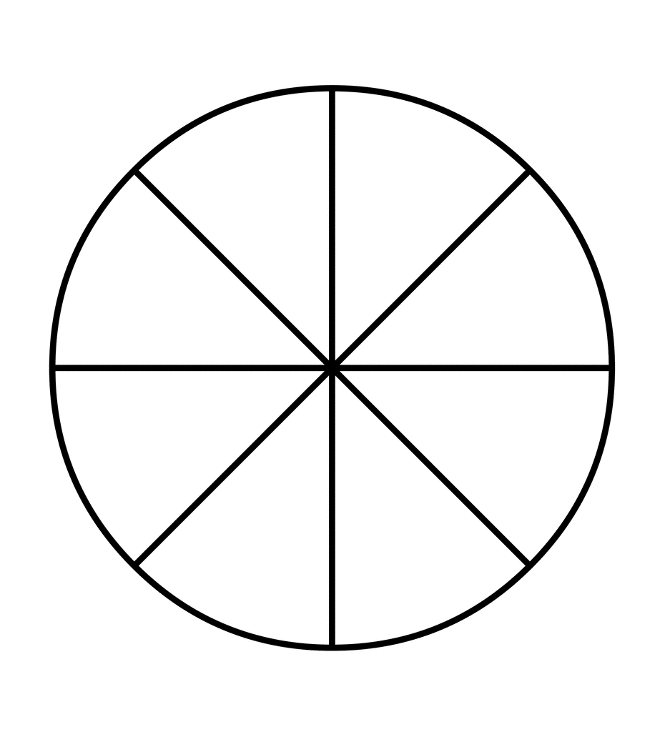 

1. Convert 3kg to grams.
2. A soccer match between P.5 and P.4 started at 2:00 pm and ended at 4:30 pm. How long did it take**?**

5. Tendo bought a bicycle at sh. 350, 000 and later sold it sh. 310,000.Calculate the loss he made.

­­­­­­­­­­­­­­­­­

1. Arrange +4, -2, 0, +1, -1 in ascending order.
2. Use “less than”, greater than or “equal to” to compare the fractions below.

$\frac{1}{3}$

**____________________**

1. Prime factorise 12 using ladder method.
2. Simplify 6p +3n –p +2n
3. Expand 241.
4. Given that set A={1, 2, 3, 4} and set B={0, 2, 4, 6, 8}
5. How many lines of folding symmetry has the figure below.
6. The cost of 2 books is sh.1000.Find the cost of 3 similar books.

1. Tell the time shown on the clock face below.

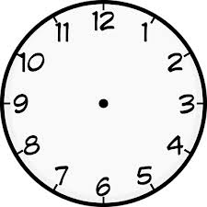

1. Complete the lattice and give the answer for 34x21.

3 4

1

2

|  |  |
| --- | --- |
|  | 0  8 |
| 0  3 |  |

1. Convert 3**** to nm improper fraction.

1. Solve for K: K +7 =15

1. Draw tallies to represent 15.
2. Bwambale is 35 years old. Write his years in Roman numerals.



1. Find the area of a triangle below.

5 cm

6cm

**SECTION B (12 QUESTIONS 60MARKS)**

1. Given that Set A = {multiples of 3 less than 10}

Set B = {1, 2, 3, 5, 6}.

1. List down the members in of setA.

(b)Represent the above information on a

Venn diagram below.

**4**

**A**

**B**

(c)How many members are in set A-B**? (01mark)**

1. (a)Tadd rod his bicycle at a speed of 60km/hr for 3 hours. Calculate the

distance he covered.

1. A motorist takes 2 hours to move a distance of 240 km. At what speed was he moving**?**

1. (a) The head teacher served 7 textbooks in each class, if he served in 7

classes, how many books did he serve altogether**?**

1. Work out:

9 7 4 6 1

-1 8 2 7 0

1. On Mutatina’s farm, there are 20 animals. $\frac{1}{4}$ of them are goats and the rest are cows.

(a)How many goats are on his farm**?**

**(**

(b) Find the fraction of cows.

1. How many more cows than goats are on Mutatina’s farm**?**

25. Study the magic square below and answer the questions that follow.

|  |  |  |
| --- | --- | --- |
| **9** | a | **7** |
| **b** | 6 | 8 |
| **5** | c | 3 |

(a)Find the magic sum.

b) Work out the value of;

1. a (ii) b (iii) c

26. (a) Calculate the square root of 16.

(b) Work out the LCM of 12 and 9.

(c) Find the GCF of 6 and 8.

27. Mary went for shopping and bought the following items.

3 **books at sh. 500 each**

**A heap of 5 tomatoes at sh. 2000**

**3 bars of soap at sh. 3000 each.**

**kg of salt at sh. 700**

(a) How much did she spend on books**?**

(b) How much does she spend on tomatoes and salt**?**

(c) How much did she spend on books than salt**?**

28. Using a pair of compasses, a sharp pencil and ruler only, construct an equilateral triangle in a circle of radius 3cm.

1. Use the number line below to answer questions that follow.

**Y**

**0**

**1**

**2**

**3**

**4**

**5**

**6**

**7**

**-1**

**-2**

**-3**

**-4**

**-5**

**-6**

**-7**

**X**

**Z**

1. Write the integers marked with letters.
2. X (ii) Y (iii) Z
3. Write the mathematical statement represented on the number line above.
4. Study the cuboid below and answer the questions that follow.

4cm

5cm

8cm

(a) Find the perimeter of the shaded part.

(b) Work out the volume of the cuboid above.

1. (a) Write 124five in words.

**A**

**B**

**0**

**1**

**2**

**3**

**4**

**5**

**6**

**7**

**-1**

**-2**

**-3**

**-4**

**-5**

**-6**

**-7**

**A**

**B**

**0**

**1**

**2**

**3**

**4**

**5**

**6**

**7**

**-1**

**-2**

**-3**

**-4**

**-5**

**-6**

**-7**

**A**

**B**

**0**

**1**

**2**

**3**

**4**

**5**

**6**

**7**

**-1**

**-2**

**-3**

**-4**

**-5**

**-6**

**-7**

(b) Add: 204five

+ 103five

1. Convert 230five to base ten.

1. Study the table below and use it to answer the questions that follow.

|  |  |  |  |  |
| --- | --- | --- | --- | --- |
| **Subjects** | **MATHS** | **SCIENCE** | **ENGLISH** | **COMPUTER** |
| **Marks** | 90 | 80 | 45 | 55 |

1. Work out the range.

1. Find the median.

1. Work out the average score.