|  |  |
| --- | --- |
| **SECTION** | **MARKS** |
| **A** |  |
| **B** |  |
| **TOTAL** |  |

**TRINITY PRIMARY SCHOOL – BUKOTO**

**REVISION WORK**

**CLASS : P.2**

**LEARNING AREA : LITERACY**

**Name:________________________________**

**Date: __________________________________**

1. **Name one member of a nuclear family.**

**____________________________________________________**

1. **Write down two building materials.**

**(i)__________________________ (ii) ________________________**

1. **Give one means of air transport.**

**______________________________________________________**

**( aeroplane , car)**

1. **Why do we have the following at home?**

|  |
| --- |
| **Description: Image result for chair  for colouring** |
| **Image result for drawing of a bed** |
| **Description: Image result for cups for colouringDescription: Image result for cups for colouring** |

1. **How do you come to school?**

**____________________________________________________**

1. **Which bird gives us eggs at home?**

**____________________________________________________**

1. **Draw these things found in the classroom.**

|  |  |  |
| --- | --- | --- |
|  |  |  |
| **broom** | **blackboard** | **chalk** |

1. **Match the following correctly:**
2. **malaria sleeping sickness**
3. **tsetse fly mosquito**
4. **cholera housefly**
5. **Use these words to answer correctly**

**(sitting on, writing with, rubbing)**

**How useful are these things in the classroom?**

1. **pencils for ___________________________________________**
2. **duster for ____________________________________________**
3. **chairs for ____________________________________________**
4. **Give two ways how we can prevent diseases.**

**(i)_____________________________________________________**

**(ii)______________________________________________________**

1. **Write two groups of people found at home.**
2. **________________________ b) ________________________**
3. **Name these immunisable diseases.**

|  |  |
| --- | --- |
| Image result for drawing of immunisable diseases | Related image |
|  |  |

1. **Match animals to their sounds.**
2. **cow quacks**
3. **pig moos**
4. **cat grunts**
5. **duck mews**

**cow ______________**

**pig ______________**

**cat ______________**

**duck ______________**

1. **Why do you go to school?**

**______________________________________________________**

1. **What do the following people do?**
2. **cleaners ___________________________________________**
3. **cooks _____________________________________________**
4. **teachers ___________________________________________**
5. **gatekeepers _______________________________________**
6. **Draw these means of transport.**

|  |  |
| --- | --- |
|  |  |
| **Train** | **boat** |

1. **Name these school symbols.**
2. 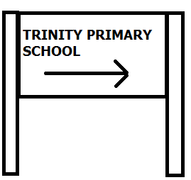 **b)** 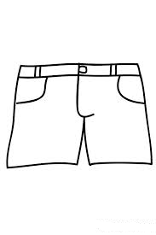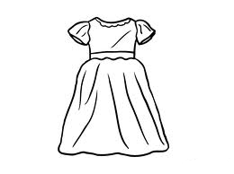

__________________________ ______________________________

**(school flag, uniform, sign post)**

1. **How can we keep our school clean?**
2. **__________________________________________________**
3. **__________________________________________________**
4. **Name these activities done at school.**

|  |  |  |
| --- | --- | --- |
|  | **ANd9GcSof7DxMzhvk1uJUdp51eAp-L6DESQ2nsz4-Sq9XbQ9Ud5FjT6nXQ** | **Description: https://encrypted-tbn3.gstatic.com/images?q=tbn:ANd9GcRwxt9AZ4OUk7H50gbQrwK7Wzw9lcBZTZh6FoiPbCprUKZs8OpB9w** |
|  |  |  |

1. **What do you call;**
2. **The mother of your mother? ________________________**
3. **Sister to your father? _______________________________**
4. **Write the uses of these things.**
5. **[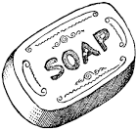](http://www.google.co.ug/imgres?imgurl=http://etc.usf.edu/clipart/19100/19127/soap_19127_lg.gif&imgrefurl=http://etc.usf.edu/clipart/19100/19127/soap_19127.htm&usg=__X2zEXi_NshsM831SBoX1qtRosa4=&h=663&w=700&sz=48&hl=en&start=20&zoom=1&tbnid=kjnNfH9gkO-xyM:&tbnh=133&tbnw=140&ei=HJa2TbyWB8ftOaXSwP4O&prev=/search?q=soap&hl=en&sa=N&gbv=2&tbm=isch&itbs=1)**

**____________________________________**

1. 

**_________________________________**

1. 

