TRINITY PRIMARY SCHOOL-BUKOTO
REVISION WORK
CLASS: P.5
SUBJECT: MATHEMATICS
TIME ALLOWED: 2HOURS 30 MINUTES
Name __________________________________________Stream __________
SECTION A: 40 MARKS
1. Work out:  $$×$$  - 1  3 |  |  | 2. Given that K = {7, 8, 9, 10}. How many members are in set K?
3. Subtract: $\frac{9}{11}- \frac{6}{11}$ |  |  | 4. Find the missing number in the  sequence.  4, 8, 12, 16, _______
5. How many days are there in 4  weeks? |  |  | 6. Solve and fill in the box.  + 200 = 700
7. the space below, draw a square  using a pencil and a ruler. |  |  | 8. David had shs. 2000. His mother gave him more shs. 1000. How much money did he have altogether?
9. Complete the table below.  Dogs 1 2 3 _____  No. of legs 4 ___ 12 20 |  |  | 10. The distance from the dining hall to the classroom is 70 metres. How far is the classroom to the dining hail in centimetres?
11.On the Venn diagram below, shade  X$∩$Y.  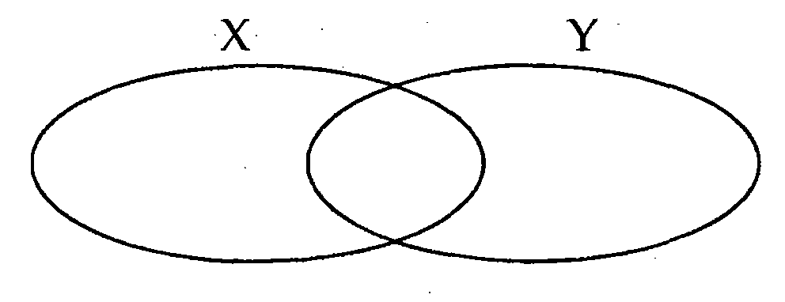 |  |  | 12. Find the number that was expanded below.  (7x1000)+(2x100)+(8x10)
13. Kayunga primary school, has 748 boys and 952 girls. Find the total number of pupils in that school. |  |  | 14. One mango costs shs. 500. How much money will you need to buy two mangoes?
15.Work out the sum of the first four odd numbers. |  |  | 16. Shade $\frac{5}{8}$ of the diagram.
17. Eighteen bananas were equally shared among a daughter, a mother and a father. How many bananas did the mother get? |  |  | 18. P = {a, b, c, d} and  Q= {1, 2, 3, 4).  Set P and Q are______________ sets
19. Write 22 in Roman numerals |  |  | 20. Write the place value of 7 in 7492.
SECTION B (12 QUESTIONS -60 MARKS)

21. Study the Venn diagram below and use it to answer the questions that follow.  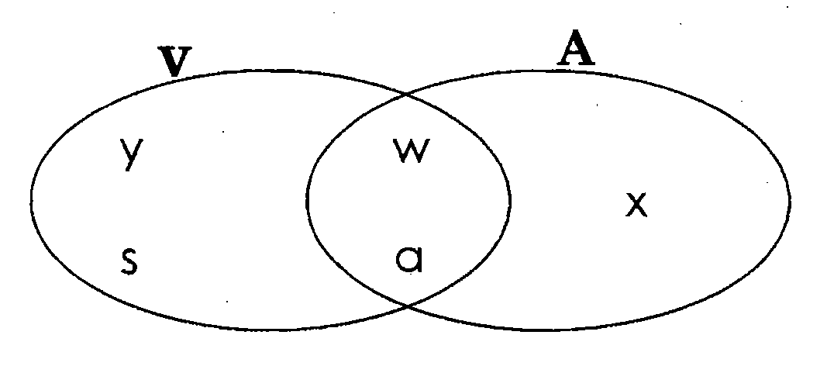  a) List the members of  - Set V __________________________________________________  - Set A __________________________________________________  - V ∩ A __________________________________________________ |  |  |  | 03marks
(b) How many members are in V U A? |  |  |  | 02marks
22. (a)Write the next number in the sequence.  (i) 0, 2, 4, 6, ___________  (ii) 18, 15, 12, 9, _________ |  |  |  | 02marks
(b) Find the LCM of 6 and 4 |  |  |  | 02marks
23. Given the number “Two hundred fifteen”  - Write the number in figures. |  |  |  | 02marks
- Represent the above number on an abacus. |  |  |  | 02marks
- Expand the given number using values. |  |  |  | 02marks
24.a) If k =3 and P =8, find the value of;  (i) P + k (ii) p -k |  |  |  | 01mark  each
b) Solve the following  (i) $m - 2=8$ |  | (ii) $n+5 =10$ |  | 02marks  each
25. Study the price list below.  A kg of rice Shs. 4000  A packet of biscuits Skis. 1500  A bar of soap Shs. 3500  - Write the cost of the cheapest item. |  |  |  | 01mak
- Find the total cost of buying a bar of soap and a packet of biscuits. |  |  |  | 02marks
- How much does it cost to buy 2kg of rice? |  |  |  | 02marks
26. Draw the shapes below.  Kite Triangle Cone |  |  |  | 02 marks  @
27.(a) At a birthday party of Max, he ate $\frac{1}{5}$ of the cake, gave $\frac{2}{5}$ to his friends and the remaining to his parents.  (i) What fraction of the cake was eaten by Max and his friends altogether? |  |  |  | 02marks
(ii) Find the fraction of the cake that he gave to his parents. |  |  |  | 02marks
(b) What is $\frac{1}{2} of 10$? |  |  |  | 02marks
28. Workout correctly.  i) 4 2 5 ii) 3 8 2  x 2 - 1 4 7 |  |  |  | 02marks each
29. (a) Change 2Metres to centimetres |  |  |  | 02 marks
(b) Change 4000g to kg |  |  |  | 02 marks
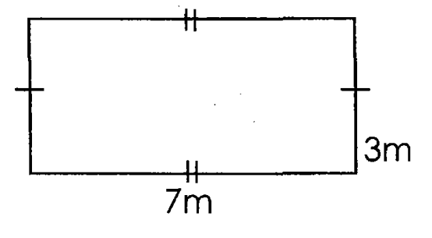
30. Use the figure below to answer the questions that follow

$$x$$

$$y$$

- Write the value of;  - Length $x$  - Width $y$ |  |  |  | 02marks
(b) Calculate the total distance round the above figure. |  |  |  | 02marks
31.The table below shows marks that Tom got in a test.  Subject Maths English Science Social studies  Marks 98 90 95 90  - How many marks did he score in Science? |  |  |  | 01mark
- In which subjects did he score the same marks? |  |  |  | 01mark
- Find the range of the marks by subtracting the lowest mark from the highest mark |  |  |  | 02marks
- Work out Tom’s total mark in all the subjects. |  |  |  | 02marks
32. (a)Tell the time  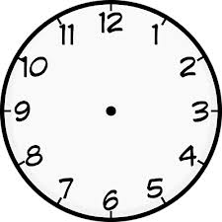 | (b) Draw clock hands to show half past 8 O’clock. |  |  | (a)  01 mark  (b)  02marks
(c) A P.4 assembly started at 7 O’clock and ended at 9 O’clock. How many hours did the assembly take? |  |  |  | 01 mark

END

