**TRINITY PRIMARY SCHOOL-BUKOTO**

|  |  |
| --- | --- |
| **For examiner’s use only** | |
| **A** |  |
| **B** |  |
| **TOTAL** |  |

**REVISION WORK**

**CLASS: P.4**

**SUBJECT: SCIENCE**

**TIME ALLOWED: 2HOURS 15 MINUTES**

Name __________________________________________Stream __________

**SECTION A: (40MARKS)**

1. **Name the garden tool used for digging.**

**___________________________________________________________**

1. **Which animal is kept at home for security?**

**­­­­­­­­­­­­­­­­**___________________________________________________________

1. **Why do we brush our teeth?**

**______________________________________________________________**

1. **Name one element of a good map.**

**________________________________________________________________**

1. **Why is it dangerous to disturb bees?**

**________________________________________________________________**

1. **How is the garden tool below useful to people?**



**_______________________________________________________________**

1. **State one cultural practice in a community.**

**________________________________________________________________**

1. **Give one danger of child abuse.**

**________________________________________________________________**

1. **How are forests important to carpenters?**

________________________________________________________________

1. **Name the place where people keep their money safe.**

**________________________________________________________________**

1. **Name any one type of transport.**

**________________________________________________________________**

1. **Identify the fruit below.**

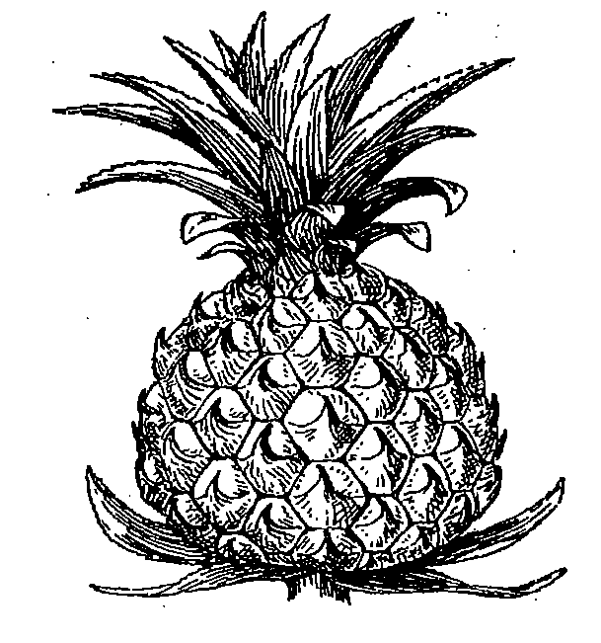**____________________________________________**

1. **Give one example of a cardinal point of a compass?**

**_______________________________________________________________**

1. **Who heads a parish?**

**______________________________________________________________**

1. **Why do animals move from one place to another?**

________________________________________________________________

1. **Apart from a School, name any other important place in the community?**

**_______________________________________________________________**

1. **Mention one danger of accidents to people.**

**_______________________________________________________________**

1. **Name the clouds that give us rain.**

________________________________________________________________

1. **Give one use of a bed in the house?**

________________________________________________________________

1. **Why should a classroom have a dustbin?**

**________________________________________________________________**

1. **Write one use of food to the body**

**­­­­­­­­­­________________________________________________________________**

1. **Why do we have chairs in the classroom?**

**________________________________________________________________**

1. **Draw the human body part used for seeing.**

|  |
| --- |
|  |
|  |

1. **Name one habitat of fish.**

**________________________________________________________________**

1. **Give one use of pots to people.**

**________________________________________________________________**

1. **In which type of family do we find uncle?**

**________________________________________________________________**

1. **Why do people keep hens at home?**

**________________________________________________________________**

1. **Write any one way soil is formed.**

**_______________________________________________________________**

1. **Name the importance place in the community where people go to buy items.**

**________________________________________________________________**

1. **Why should water for drinking be boiled?**

**________________________________________________________________**

1. 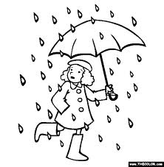**Identify the type of weather shown in the diagram below.**

**_____________________________________**

1. **How is a housefly dangerous to people?**

**­________________________________________________________________**

1. **How is a police man useful to the community?**

**________________________________________________________________**

1. **Give one way people can care for their hair.**

**______________________________________________________________**

1. **Name any one item we can use to make ropes.**

**_______________________________________________________________**

1. **Give any one way farming is important to people.**

**______________________________________________________________**

1. **What does the symbol below represent?**

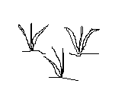**________________________________________________**

1. **What do we call a young cow?**

**______________________________________________________________**

1. **Name part of the insect marked x**

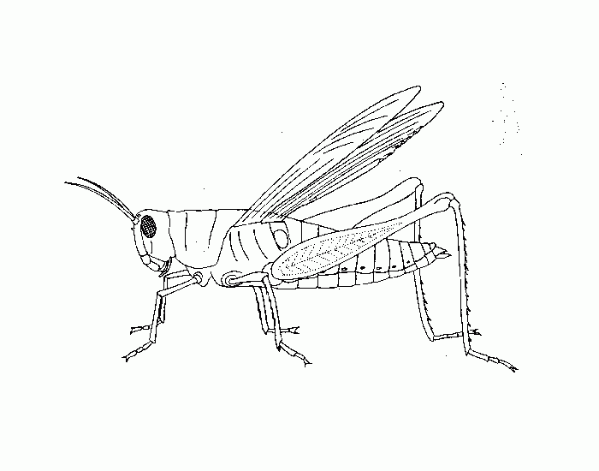

**x**

**____________________________________________________________**

1. **State any one importance of a balanced diet.**

**________________________________________________________________**

**SECTION B: (60 MARKS)**

1. **(a) What is transport**

**________________________________________________________________________________________________________________________________**

**(b) Apart from road transport, write any other two types of transport. (i)_________________________(ii) _________________________________**

**(c) Name any one means of road transport.**

**_______________________________________________________________**

1. **(a) Name the three main body parts of an insect**
2. **_________________ (ii) __________________(iii) ________________**

**(b) On which main body part of an insect are the wings found? ________________________________________________**

1. **(a) Name two crops grown in swamps.**
2. **______________________________________________________**

**(ii) ______________________________________________________**

**(b)Why is it not good to settle in swamps?**

_____________________________________________________________

1. **Mention one building material got from swamps.**

**_____________________________________________________________**

1. **(a) What is a nuclear family?**

**________________________________________________________________________________________________________________________________**

**(b) List any two members of a nuclear family.**

**(i) ____________________________________________________________**

**(ii) ____________________________________________________________**

**(c)Apart from the nuclear family, name any other type of family.**

**____________________________________________________________**

1. **(a) Write any two agents of soil erosion.**

**(i) ___________________________________________________**

**(ii) ____________________________________________________**

**b) How do famers control soil erosion in the garden?**

**__________________________________________________________**

**c) Name one activity that causes soil erosion.**

**____________________________________________________________**

1. **(a) How can wind be useful to people?**

**____________________________________________________________**

**(b) Write any two dangers of strong wind.**

**(i) _________________________________________________________**

**(ii) _________________________________________________________**

**(c) How can we protect the environment?**

**___________________________________________________________**

1. 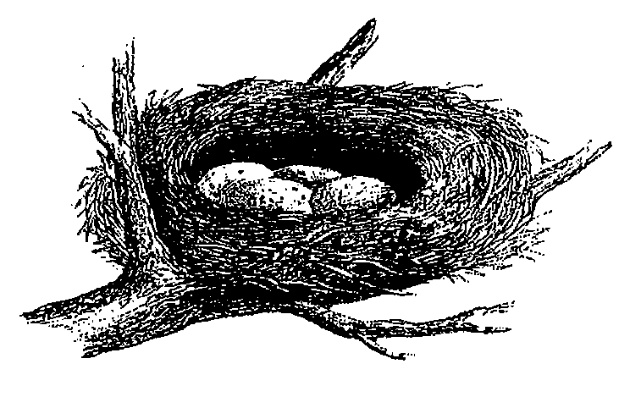**Below is a diagram of an animal habitat. Use it to answer questions that follow.**

**(a) Identify the above animal home.**

**_____________________________________________________________**

**(b) Name the animal that lives in the above habitat.**

**_____________________________________________________________**

**(c) Write two materials used to make the above habitat.**

**(i)________________________ (ii) ____________________________**

1. **(a) Give any one use of a house at home.**

**_____________________________________________________________**

**(b) Name any two materials we use when building a house.**

**(i) ______________________________________________**

**(ii) ______________________________________________**

**(c) Mention any one thing found in a sitting room.**

**___________________________________________________________**

1. **Match the animals to their young ones.**

**Animal Young one**

**i) Cat Calf**

**ii) Dog Kitten**

**iii) Cow kid**

**iv) Goat Puppy**

1. **(a) Write the main source of water in the environment.**

**___________________________________________________________**

**(b) State any two ways water can get dirty.**

**(i) _______________________________________________________**

**(ii) _______________________________________________________**

**(c) Give one use of water at home.**

**____________________________________________________________**

1. **(a) Name any two insects that can be eaten.**

**i) ___________________________________________________**

**ii) ___________________________________________________**

1. **Mention one insect without wings.**

**__________________________________________________________**

1. **How many legs does an insect have?**

**___________________________________________________________**

1. **(a) Write any one way people care for their beddings.**

**_____________________________________________________________**

**(b) Give two activities we do to keep our bodies clean.**

**i) ______________________________________________________**

**ii) ______________________________________________________**

**(c) Name one material we use to keep our bodies clean.**

**_______________________________________________________**

1. **The diagram below is of a tool used in giving first aid. Use it to answer question 54.**
2. **Name the equipment.**

**_____________________________________________________________**

**(b) Identify two tools kept in the equipment above?**

**(i) _________________________________________________________**

**(ii) _________________________________________________________**

**c) Give one accident that may cause bleeding.**

**________________________________________________________________**

1. **(a) Name any two elements of weather.**

**(i) __________________________________________________________**

**(ii) __________________________________________________________**

**(b) Give any two types of weather.**

**(i) __________________________________________________________**

**(ii) __________________________________________________________**

1. **(a) What is a map?**

**__________________________________________________________________________________________________________________________**

**(b) How are maps important to people?**

**________________________________________________________________________________________________________________________________**

**(c) Draw a map of the following;**

|  |  |
| --- | --- |
|  |  |
| **tree** | **table** |

End